Kinetic Heuristic Encryption for Perimeter-Resilient Agents (KHEPRA)
Provisional Patent Application ID# 73565085
SGT Kone, Souhimbou, Doh
Candidate of Master of Science Digital Forensics & Cybersecurity
Cybersecurity Architect & Cryptography, AI/ML, Quantum Computing Researcher
17/12/2025

PROVISIONAL PATENT APPLICATION (ID# 73565085)
TECHNICAL TITLE OF THE INVENTION:
"Kinetic Heuristic Encryption for Perimeter-Resilient Agents (KHEPRA): System and Method for Agentic Security Attestation (ASAF) using Adinkra Symbol-Based Post-Quantum Cryptography"
INVENTOR INFORMATION
Primary Inventor: Souhimbou Doh. Kone

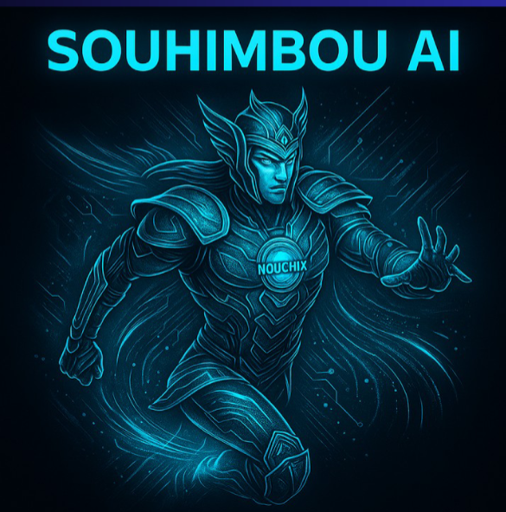

CROSS-REFERENCE TO RELATED APPLICATIONS
Not Applicable.
STATEMENT REGARDING FEDERALLY SPONSORED RESEARCH OR DEVELOPMENT
Not applicable.
View attached documentation:
KHEPRA Protocol – Invention Origin & Ownership Preservation Dossier (AR 27-60)

TABLE OF CONTENTS
1. FIELD OF THE INVENTION ................................................
2. BACKGROUND OF THE INVENTION .....................................
2.1 Technical Problem Domain .............................................
2.2 Limitations of Existing Solutions (Prior Art) ....................
2.3 Gap Analysis and Invention Necessity ..............................
3. SUMMARY OF THE INVENTION ........................................
3.1 Adinkra Algebraic Encoding (AAE) ..................................
3.2 Quantum-Resilient Key Exchange (QKE) ............................
3.3 Agent Consensus Protocol (ACP) ....................................
3.4 Physics-Inspired Validation Framework ...........................
3.5 Zero Trust Integration .............................................
3.6 Multi-Language Production Framework ..............................
4. BRIEF DESCRIPTION OF THE DRAWINGS ...............................
A. General Architecture and Overview...........................
FIG. 1 Overall KHEPRA System Architecture...........................

B. Adinkra Algebraic Encoding (AAE) and QKE Protocol...........................
FIG. 2 Mapping Adinkra Symbols to $\mathbf{D_8}$ Dihedral Symmetry...........................
FIG. 3 Symbol-Derived Key Generation Pipeline...........................
FIG. 4 PQ Key Exchange Flow (ML-KEM-ready) ...........................

C. Agent Consensus Protocol (ACP) and Validation...........................
FIG. 5 Agent Consensus DAG Structure with Glyph-Triggered Execution...........................
FIG. 6 Lorentz-Invariant Timestamping Diagram...........................

D. Zero Trust Integration and Use Cases ...........................
FIG. 7 Zero-Trust Enforcement Lifecycle for Autonomous Agents...........................
FIG. 8 DoD Enclave Authentication Flow (Eban Handshake) ...........................
FIG. 9 SATCOM Adaptive Rekeying and Station Handoff...........................
FIG. 10 Regulators / Compliance Mapping Using Symbol Semantics ...........................

E. Prior Art Comparison...........................
FIG. 11A Prior Art Confidential Compute Attestation...........................
FIG. 11B KHEPRA Protocol Agentic Security Attestation Framework (ASAF) ...........................
FIG. 11C Combined Comparison: Prior Art vs. KHEPRA...........................

5. DETAILED DESCRIPTION OF THE INVENTION ..........................
5.1 Adinkra Algebraic Encoding (AAE) System .........................
5.1.1 Symbol Selection and Cultural Context .....................
5.1.2 Mathematical Construction ..................................
5.1.3 Cryptographic Parameter Derivation ........................
5.1.4 Key Derivation Function (KHEPRA-KDF) .......................
5.2 Quantum-Resilient Key Exchange (QKE) Protocol ...................
5.2.1 Four-Phase Protocol Overview ...............................
5.2.2 Phase 1: Initialization ....................................
5.2.3 Phase 2: Encapsulation .....................................
5.2.4 Phase 3: Decapsulation .....................................
5.2.5 Phase 4: Confirmation and Audit Trail ......................
5.2.6 Security Properties ........................................
5.3 Agent Consensus Protocol (ACP) ...................................
5.3.1 DAG Structure and Glyph Triggers ...........................
5.3.2 Conflict Resolution via Symbol Precedence ..................
5.3.3 Causal Consistency Guarantees ..............................
5.4 Physics-Inspired Validation Layer ................................
5.4.1 Lorentz-Invariant Message Flow .............................
5.4.2 Category-Theoretic Consistency .............................
5.4.3 Supersymmetric Pairing .....................................
5.5 Zero Trust Integration ...........................................
5.5.1 Continuous Authentication Flow .............................
5.5.2 Multi-Layered Trust Scoring ................................
5.5.3 Just-In-Time Privilege Escalation ..........................

6. SOFTWARE FRAMEWORK IMPLEMENTATION ...............................
6.1 Go-Based Production Core .........................................
6.1.1 Architecture Overview ......................................
6.1.2 Core Modules ...............................................
6.1.3 SSH/Git Integration Module .................................
6.2 Python Integration Layer .........................................
6.2.1 gRPC Service Architecture ..................................
6.2.2 cryptography.io Compatibility ..............................
6.3 Kubernetes Native Deployment .....................................
6.3.1 Helm Chart Architecture ....................................
6.3.2 ServiceAccount Integration .................................
6.3.3 Admission Control Webhooks .................................
7. USE CASE IMPLEMENTATIONS ..........................................
7.1 DoD Agent Authentication .........................................
7.2 Satellite Communication ..........................................
7.3 Kubernetes Enterprise Deployment .................................
7.4 Git/SSH Development Workflow .....................................
8. ADVANTAGES OF THE INVENTION ......................................
9. CLAIM SUMMARY (PROVISIONAL) ......................................
Claim 1 - System Architecture .......................................
Claim 2 - Key Exchange Method ........................................
Claim 3 - Consensus Method ...........................................
Claim 4 - Zero Trust Authentication ..................................
Claim 5 - Software Framework .........................................
10. ABSTRACT .........................................................
11. CONTINUATIONS CONCEPTS .......................................................
12. REFERENCES ...........................................
APPENDICES
Appendix A: Mathematical Derivations ................................
Appendix B: Algorithm Pseudocode ....................................
Appendix C: Security Proofs .........................................
INVENTOR DECLARATION

1. FIELD OF THE INVENTION
This invention relates to cryptographic systems, distributed consensus mechanisms, and explainable artificial intelligence security frameworks for autonomous agents. More specifically, the invention provides a novel cryptographic protocol, the KHEPRA Protocol (Kinetic Heuristic Encryption for Perimeter-Resilient Agents)—that integrates:
- Symbolic algebra derived from West African Adinkra mathematical traditions.
- Quantum-resistant lattice-based cryptography (PQC).
- Directed Acyclic Graph (DAG) consensus mechanisms.
- Physics-inspired validation frameworks.
- Zero Trust Architectures (ZTA).
Technical Problem Domain Applications
The invention addresses secure communications for autonomous AI agents in mission-critical cyber-physical environments, including:
- Department of Defense (DoD) classified networks.
- Satellite communication systems (LEO/GEO).
- Industrial control systems (SCADA, ICS, OT).
- Autonomous vehicle fleets and swarm robotics.
- Financial trading and blockchain networks.
Technical Field Classification
The technical field encompasses:
- Cryptography (CPC Class H04L 9/00): PQC protocols, lattice-based KEM/signatures.
- Distributed Computing (CPC Class G06F 9/00): Consensus protocols, DAGs.
- Artificial Intelligence Security (CPC Class G06N 20/00): Explainable AI, agent authentication.
- Zero Trust Architecture (CPC Class H04L 63/00).
Technical Solution Advantages
The KHEPRA Protocol provides:
- Post-quantum cryptographic security with mathematical explainability (symbolic traceability).
- Continuous trust verification for autonomous agents operating at machine speed (milliseconds).
- Immutable audit trails suitable for regulatory compliance (NIST SP 800-207, CMMC, HIPAA, etc.).
- High-throughput consensus ($\text{10,000+}$ transactions per second) with causal consistency guarantees.

2. BACKGROUND OF THE INVENTION
2.1 Technical Problem Domain
Challenge 1: Quantum Computing Threat to Current Cryptography
- Problem: Current public-key crypto (RSA-2048, ECC P-256) is vulnerable to Shor's algorithm on Cryptographically-Relevant Quantum Computers (CRQCs).
- Limitation of PQC Standards (FIPS 203, 204, 205): These standards (ML-KEM, ML-DSA, SLH-DSA) are opaque. They lack integration with symbolic reasoning or explainability frameworks; cryptographic operations remain "black boxes" unsuitable for contextual tagging or symbol-based policy encoding.
Challenge 2: Explainability Deficit in AI Security Systems
- Problem: AI-driven security systems are "black boxes," violating regulatory requirements like GDPR Article 22 (Right to explanation) and NIST AI RMF.
- Limitation of Existing XAI Techniques (LIME, SHAP): They provide post-hoc interpretations of machine learning models, but cannot explain cryptographic operations themselves. The fundamental gap is the inability for an audit to answer: "Why was this specific cryptographic key generated?"
Challenge 3: Continuous Agent Authentication at Machine Speed
- Problem: Autonomous agents require authentication in milliseconds, not seconds. Existing ICAM systems (DoD PKI, OAuth 2.0, Kerberos) are human-centric, creating gaps in:
  - Speed: Latency too high.
  - Frequency: Not continuous (requires periodic re-authentication).
  - Context Adaptation: Relies on static roles, not dynamic operational context.
Challenge 4: Temporal Integrity in Distributed Cyber-Physical Systems
- Problem: Geographically dispersed agents (e.g., satellites with $\text{250-1000ms}$ latency) are vulnerable to causality violations and backdated transaction attacks.
- Limitation of Current Consensus (Blockchain, PBFT, DAG): Blockchain is too slow ($\text{10}$ minutes/block). Traditional BFT doesn't scale. Existing DAGs (Hedera, IOTA) have opaque consensus decisions and rely on synchronized clocks without a cryptographic proof of causality.
Challenge 6: Cultural Monoculture Limiting Cryptographic Innovation
- Problem: Cryptographic systems are developed exclusively through Western mathematical traditions (group theory, number theory). This misses opportunities for novel security properties and symbolic reasoning offered by non-Western frameworks, such as the bipartite graph structures and supersymmetric properties found in Adinkra Symbols (S.J. Gates, 2005).

2.3 Gap Analysis and Invention Necessity
KHEPRA is the first integrated framework that simultaneously meets all critical requirements, resolving the impossible trilemma of achieving Quantum Security OR Explainability OR Scalability.
Requirement | NIST PQC | Zero Trust (SP 800-207) | DAG Consensus | KHEPRA
Quantum Resistance | ✓ | ✗ | ✗ | ✓
Native Explainability | ✗ | ◐ (Policy) | ✗ | ✓
Agent-Specific Auth | ◐ | ✓ | ◐ | ✓
High-Throughput Consensus | ✗ | ✗ | ✓ | ✓
Temporal Integrity | ✗ | ✗ | ◐ | ✓
Symbolic Policy | ✗ | ✗ | ✗ | ✓

3. SUMMARY OF THE INVENTION
The KHEPRA Protocol integrates five key subsystems:
- 3.1 Adinkra Algebraic Encoding (AAE): Maps symbols to algebraic structures, deriving security parameters.
- 3.2 Quantum-Resilient Key Exchange (QKE): Lattice-based crypto enhanced with Adinkra transformations.
- 3.3 Agent Consensus Protocol (ACP): DAG consensus with semantic glyph triggers for ordering.
- 3.4 Physics-Inspired Validation Framework: Applies Lorentz invariance for temporal integrity.
- 3.5 Zero Trust Integration: Continuous, risk-adaptive authentication.

4. BRIEF DESCRIPTION OF THE DRAWINGS
FIG. 1 — Illustrates the Overall KHEPRA System Architecture and data flow, showing the dependency sequence from the Symbol Layer to the Zero Trust Engine.
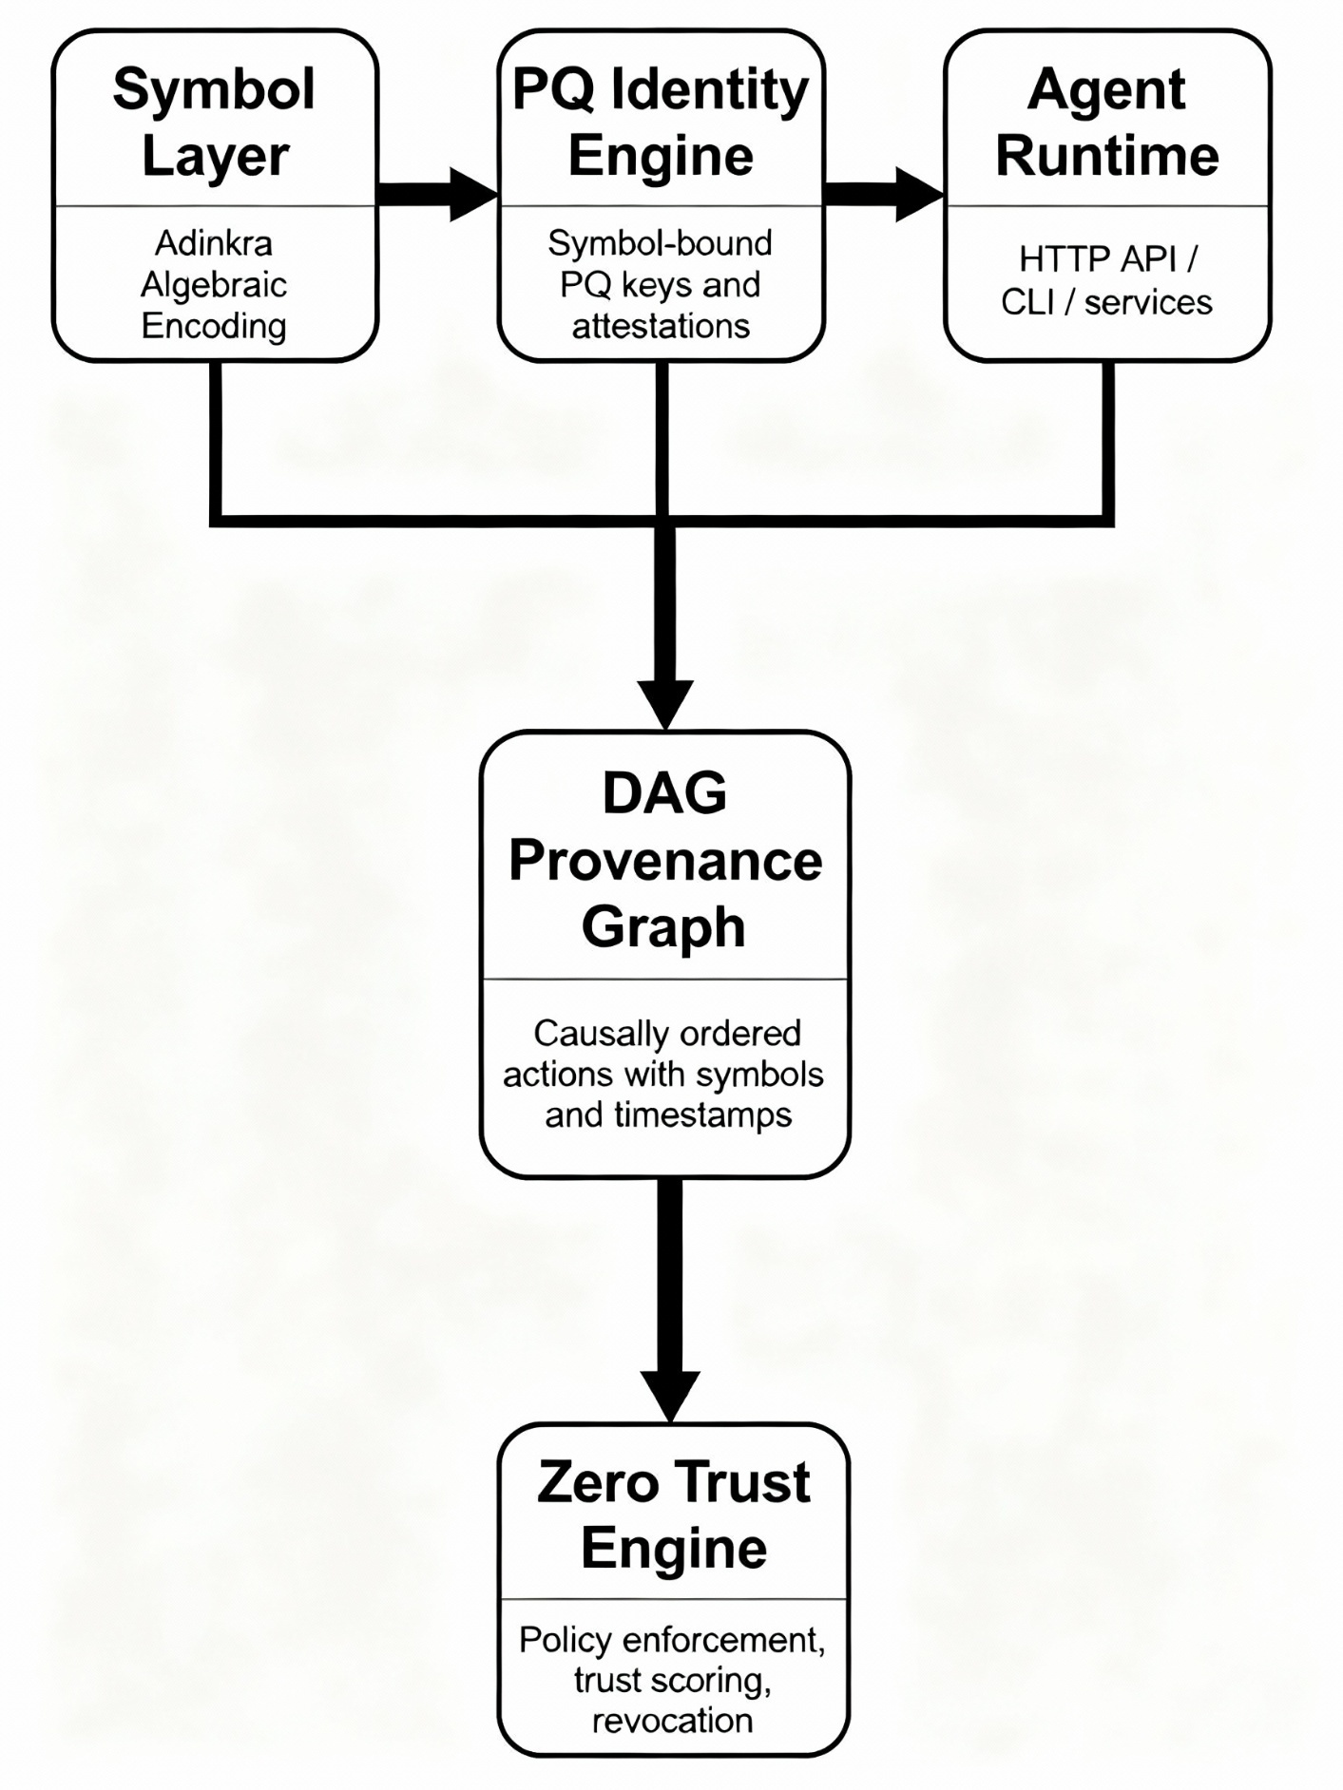

FIG. 2 — Details the Adinkra Algebraic Encoding (AAE), mapping the bipartite graph structures of key symbols (Eban, Fawohodie, Nkyinkyim) to their algebraic representations and the $\mathbf{D_8}$ Dihedral Group operations.
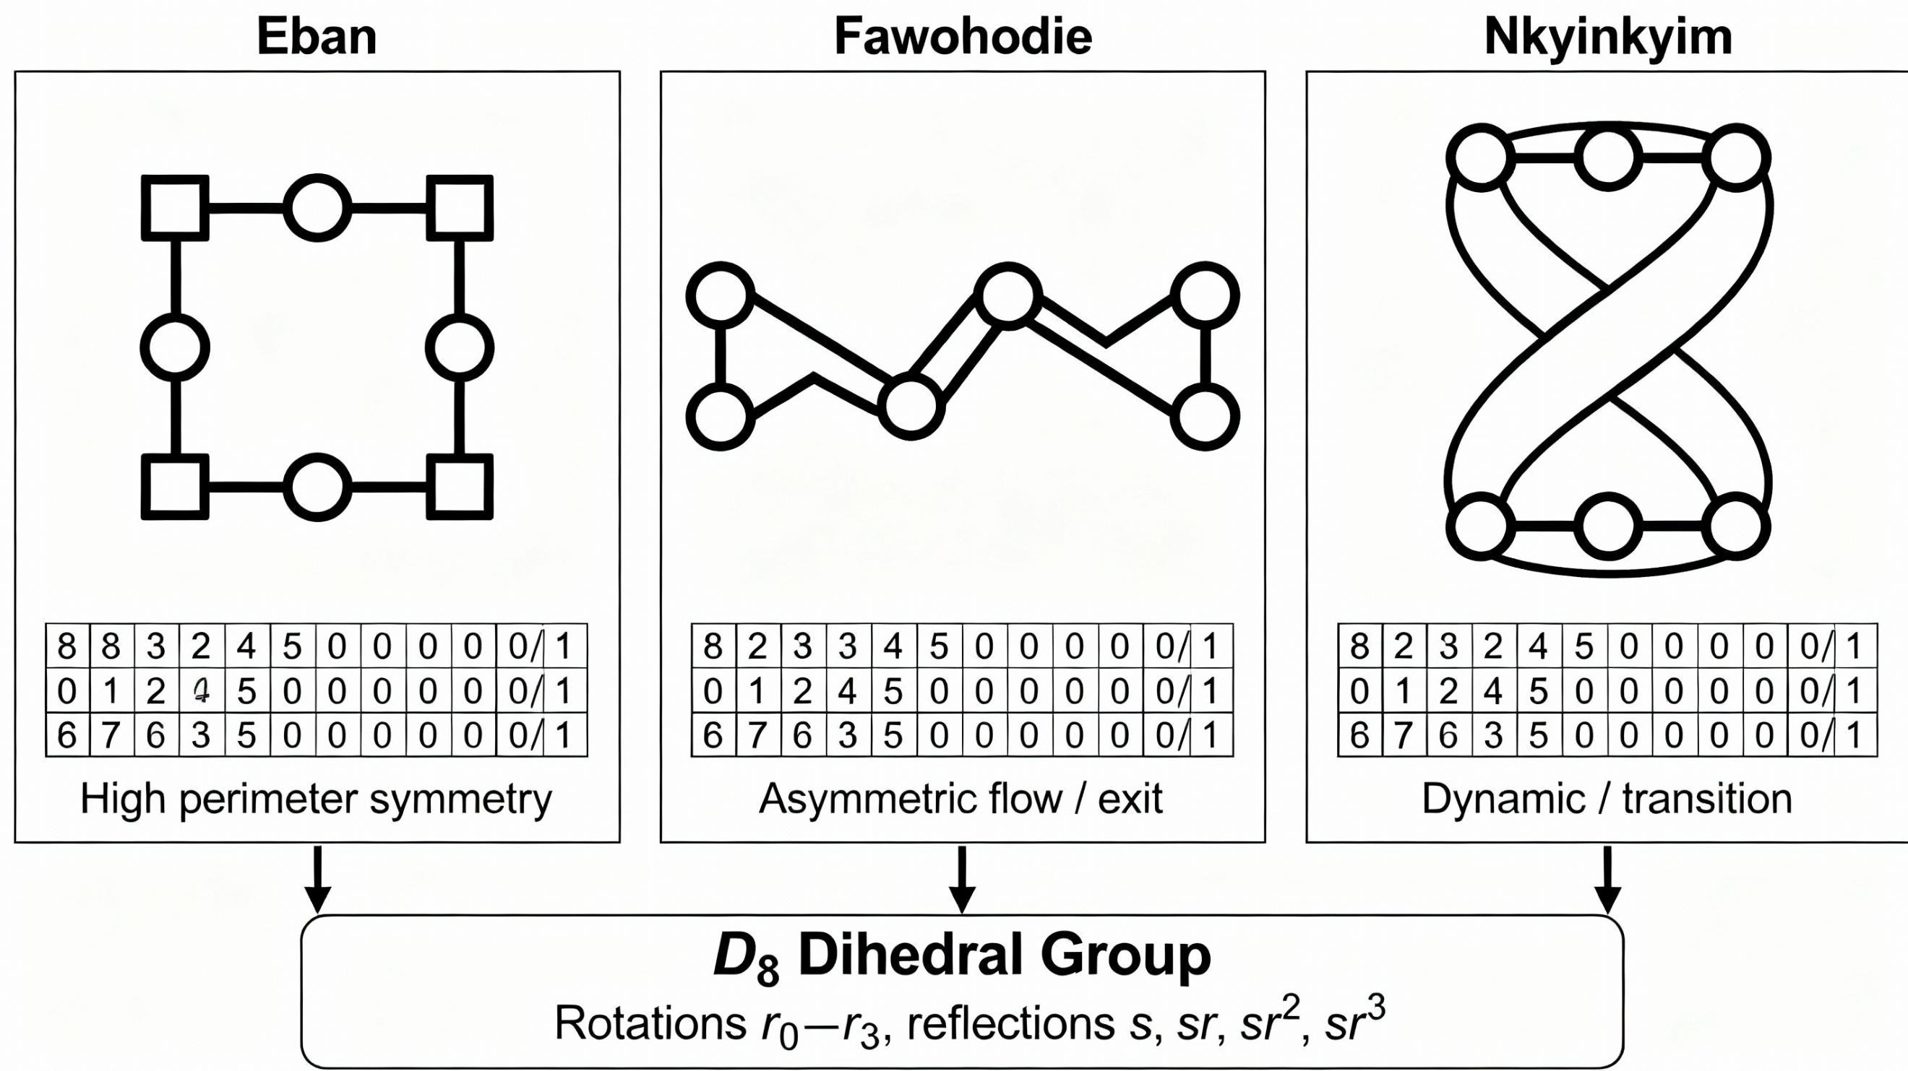

FIG. 3 — Provides the flow chart for the Symbol-Derived Key Generation Pipeline, showing the process from Adinkra Symbol selection to the derivation of the entropy seed, candidate primes, and the final $\mathbf{KHEPRA}$ Key Material.
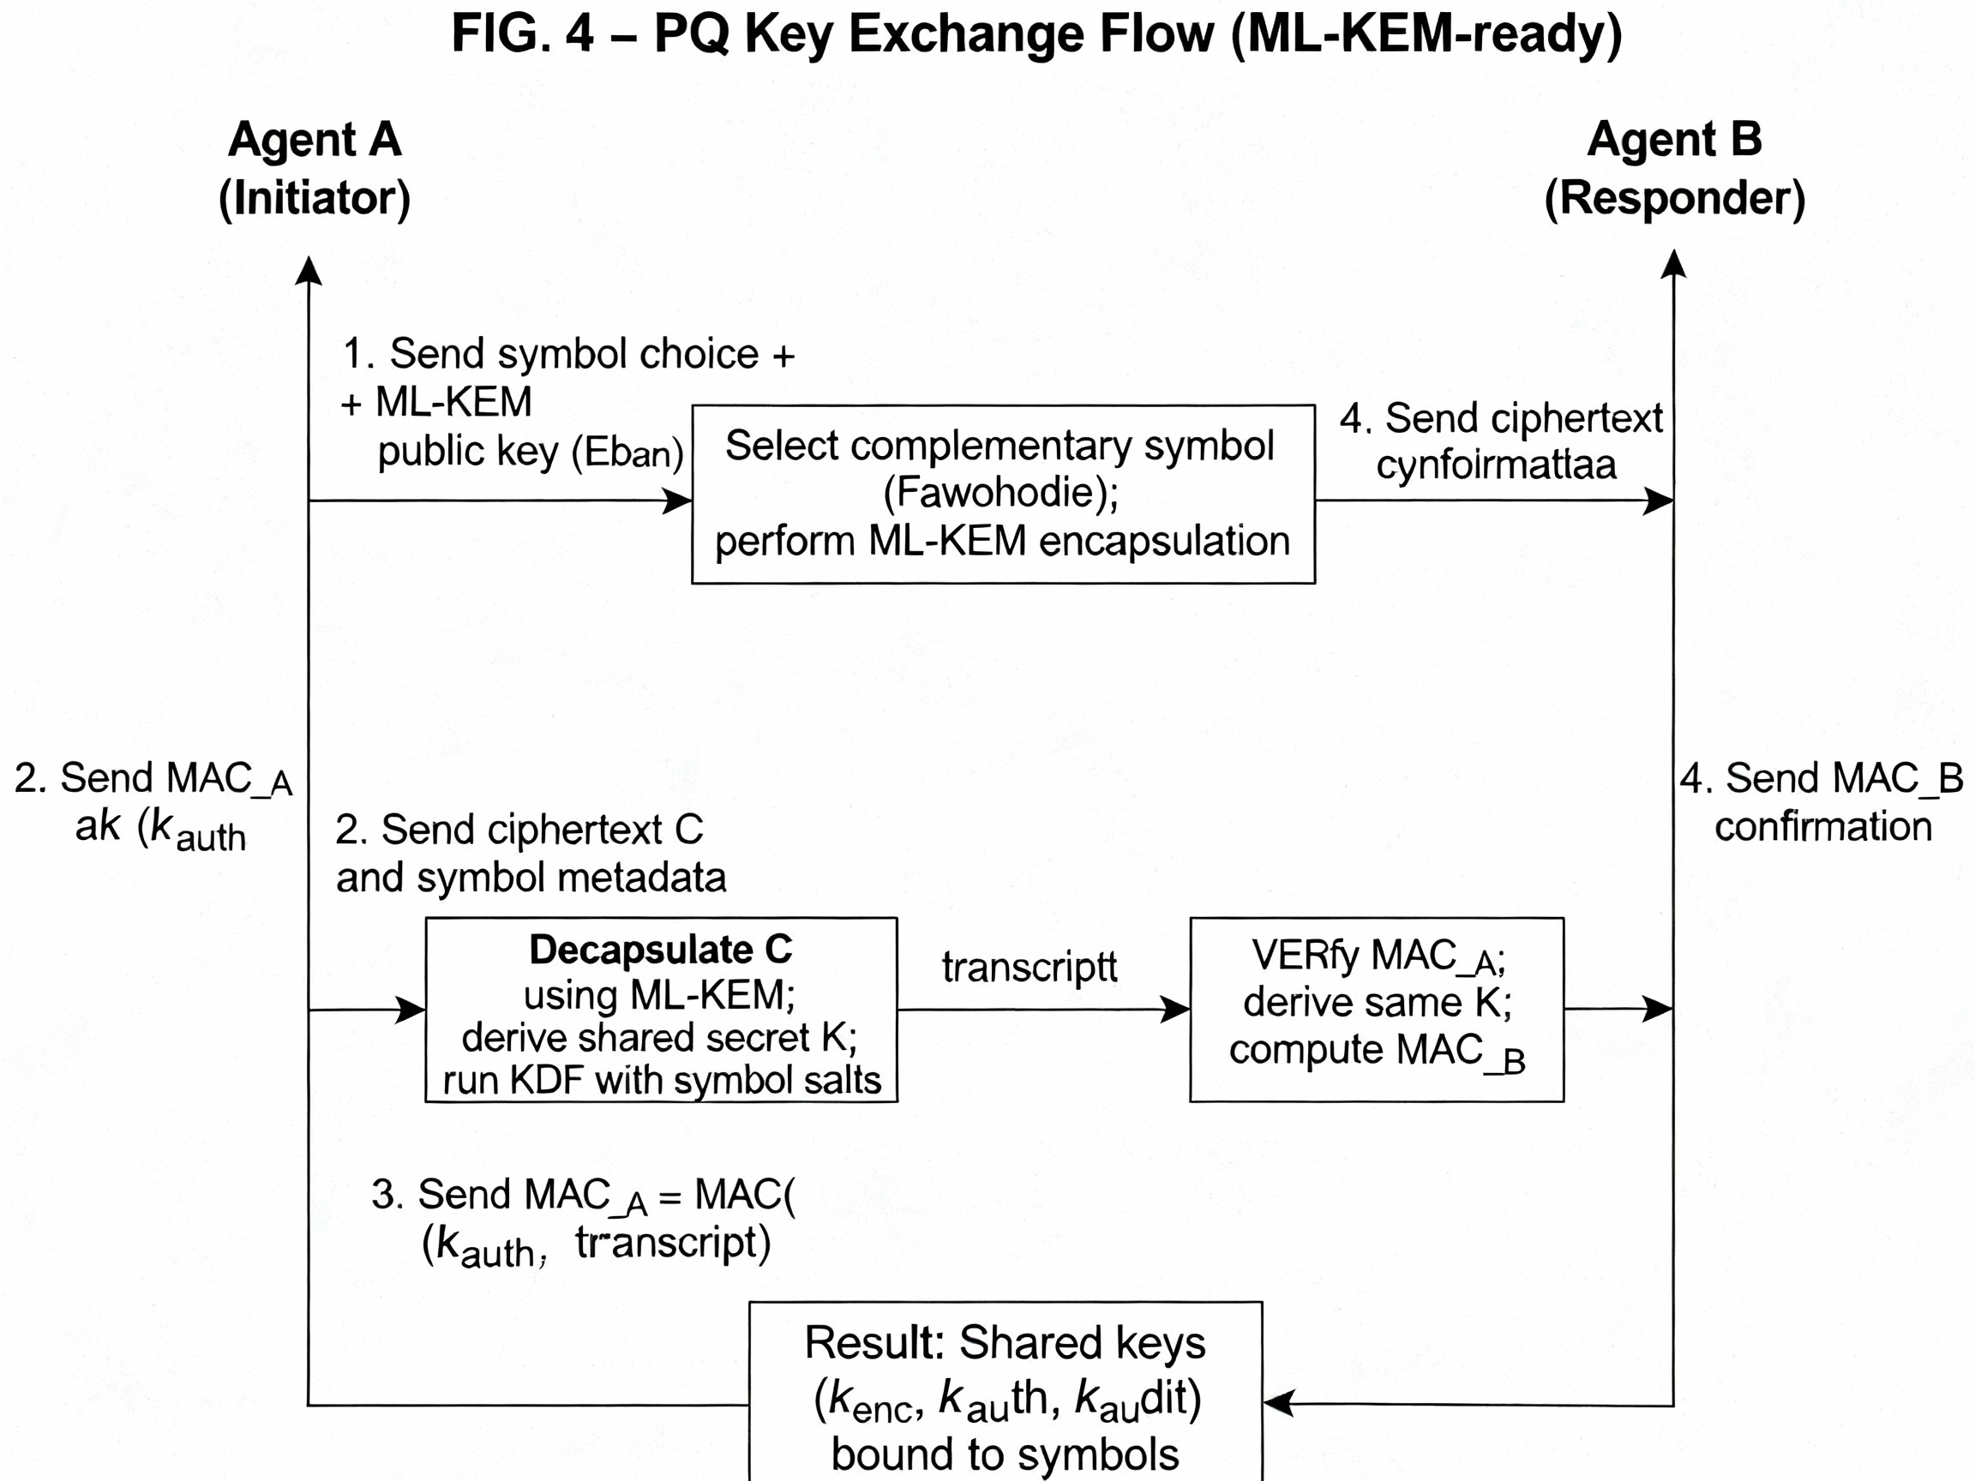

FIG. 4 — Illustrates the Post-Quantum Key Exchange Flow (ML-KEM-ready), showing the four-step sequence between Agent A and Agent B, and the final derivation of the shared keys $\{k_{\text{enc}}, k_{\text{auth}}, k_{\text{audit}}\}$ bound to symbolic salts.


FIG. 5 — Depicts the structure of the Agent Consensus Protocol (ACP) DAG, showing transaction vertices (Tx) linked by causal arrows, and illustrating how conflicts are resolved based on the Glyph Precedence Rules ($\text{Eban} > \text{Fawohodie} > \text{Nkyinkyim}$).
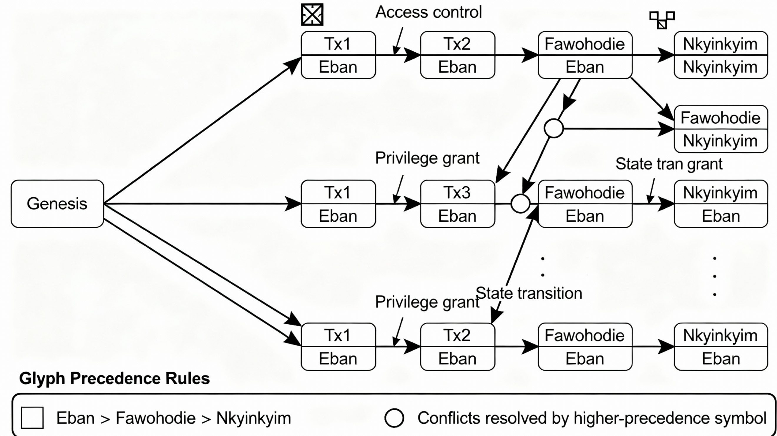

FIG. 6 — Is the Lorentz-Invariant Timestamping Diagram, showing the spacetime cone used by the Physics-Inspired Validation Layer to enforce causality by checking that actions remain within the causally allowed region ($\Delta s^2 \ge 0$).
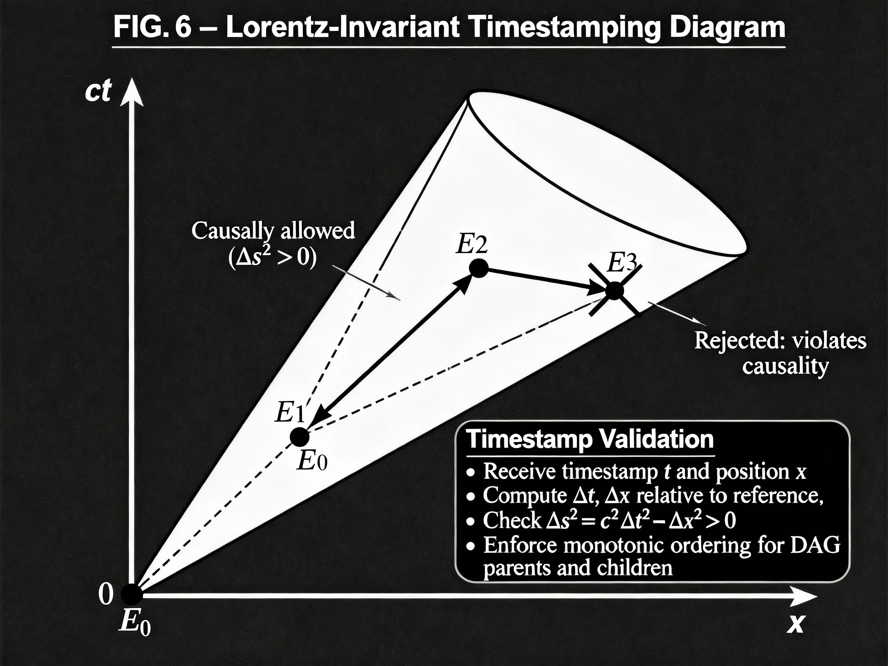

FIG. 7 — Illustrates the continuous flow diagram of the Zero Trust Engine, detailing the $\mathbf{Continuous}$ $\mathbf{Authentication}$ $\mathbf{Loop}$ from Initial Authentication to Token Refresh, Monitored State, and eventual Session Termination or Re-Authentication.
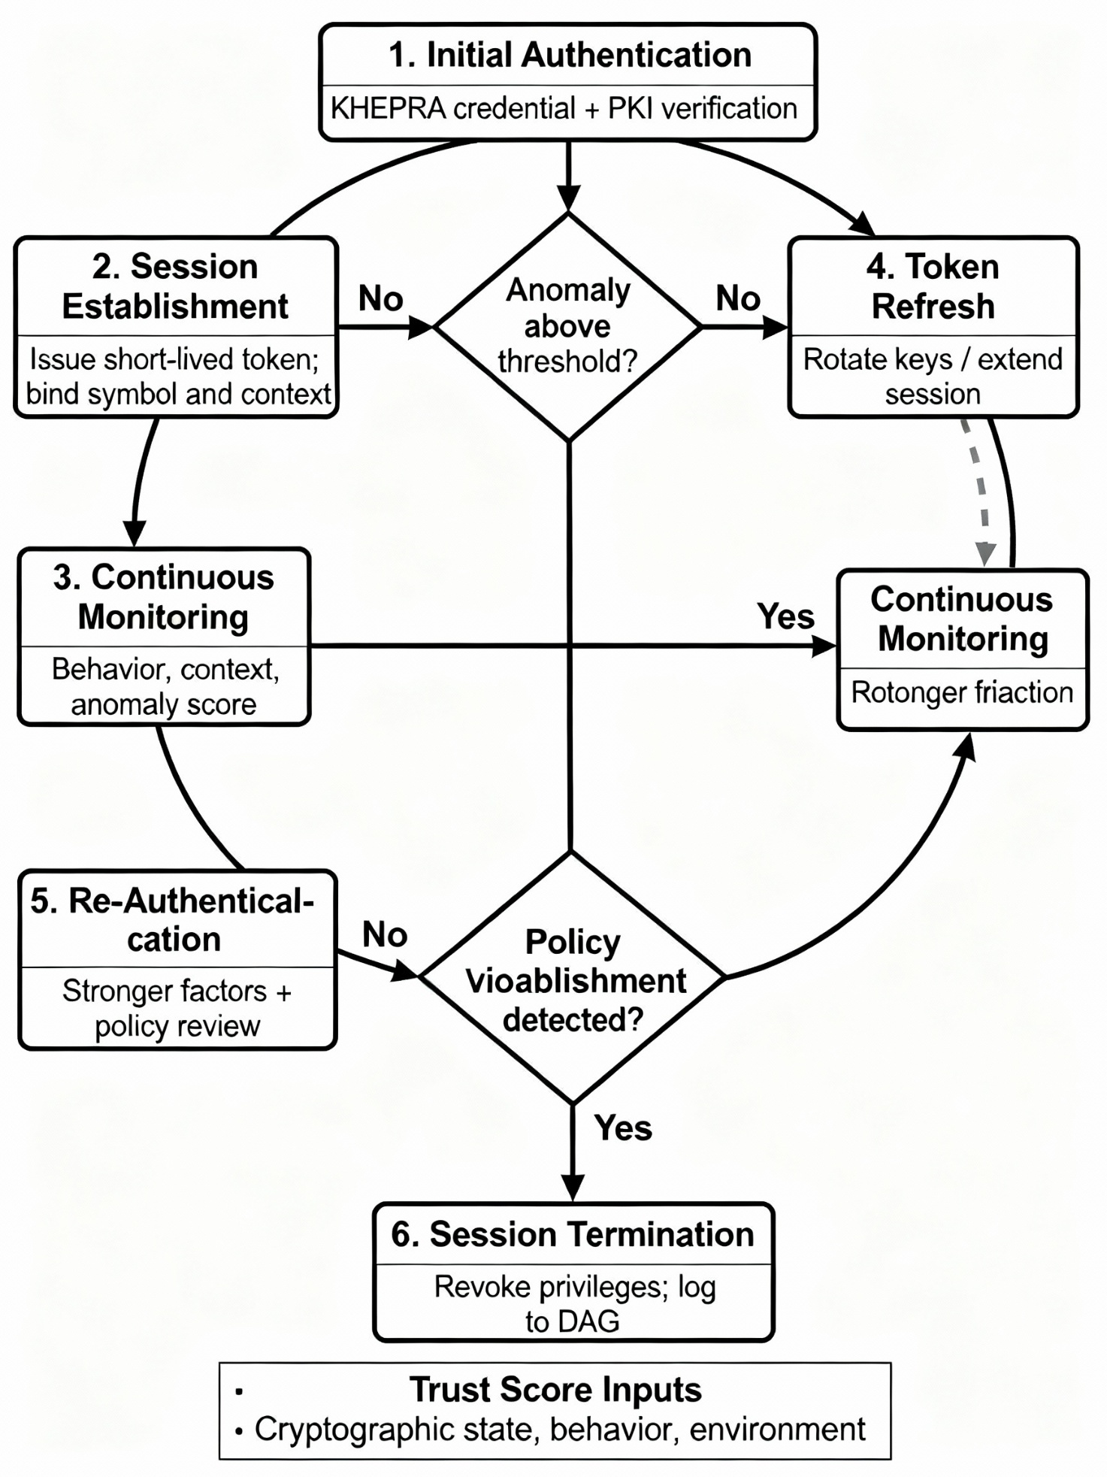

FIG. 8 — Shows a DoD Enclave Authentication Flow (Eban Handshake), detailing the use case where a Field Agent presents an $\mathbf{Eban}$ $\mathbf{Symbol-Bound}$ $\mathbf{Credential}$ to an Access Gateway, triggering a continuous monitoring loop and a policy decision based on the Trust Score.

\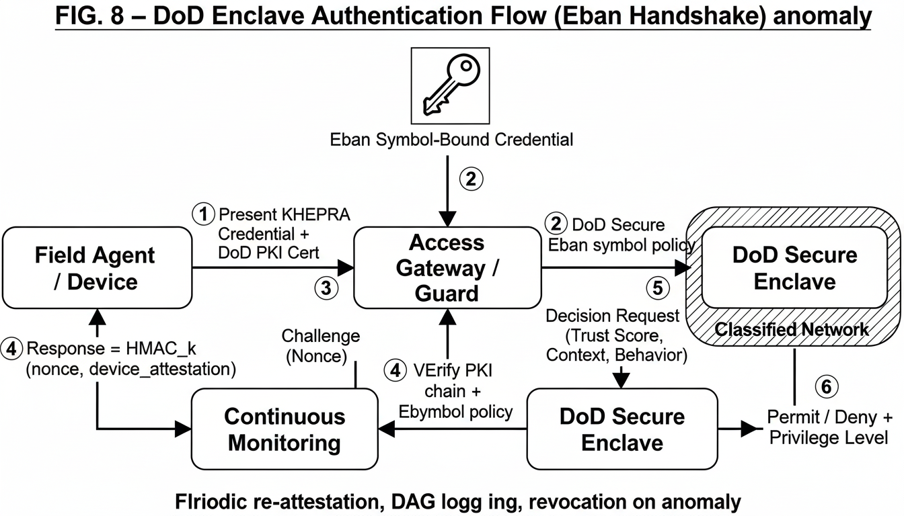

FIG. 9 — Illustrates the SATCOM Adaptive Rekeying and Station Handoff use case, detailing the dual-key window ($K_0+K_1$ valid) and the use of the $\mathbf{Nkyinkyim}$ symbol to trigger a rekey event based on factors like data volume or $\text{BER}$ (Bit Error Rate).
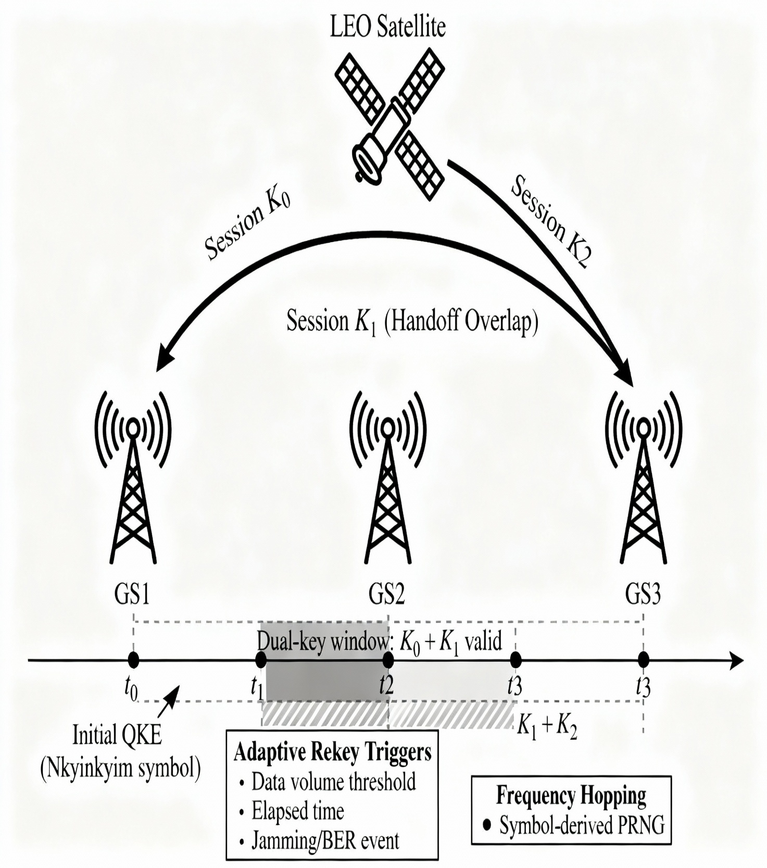

FIG. 10 — Depicts the mapping of various Regulators/Compliance Requirements (CMMC, HIPAA, GDPR, etc.) to the core $\mathbf{Symbolic}$ $\mathbf{Policy}$ $\mathbf{Mapping}$ $\mathbf{Engine}$, demonstrating how compliance rules are enforced via symbol semantics.
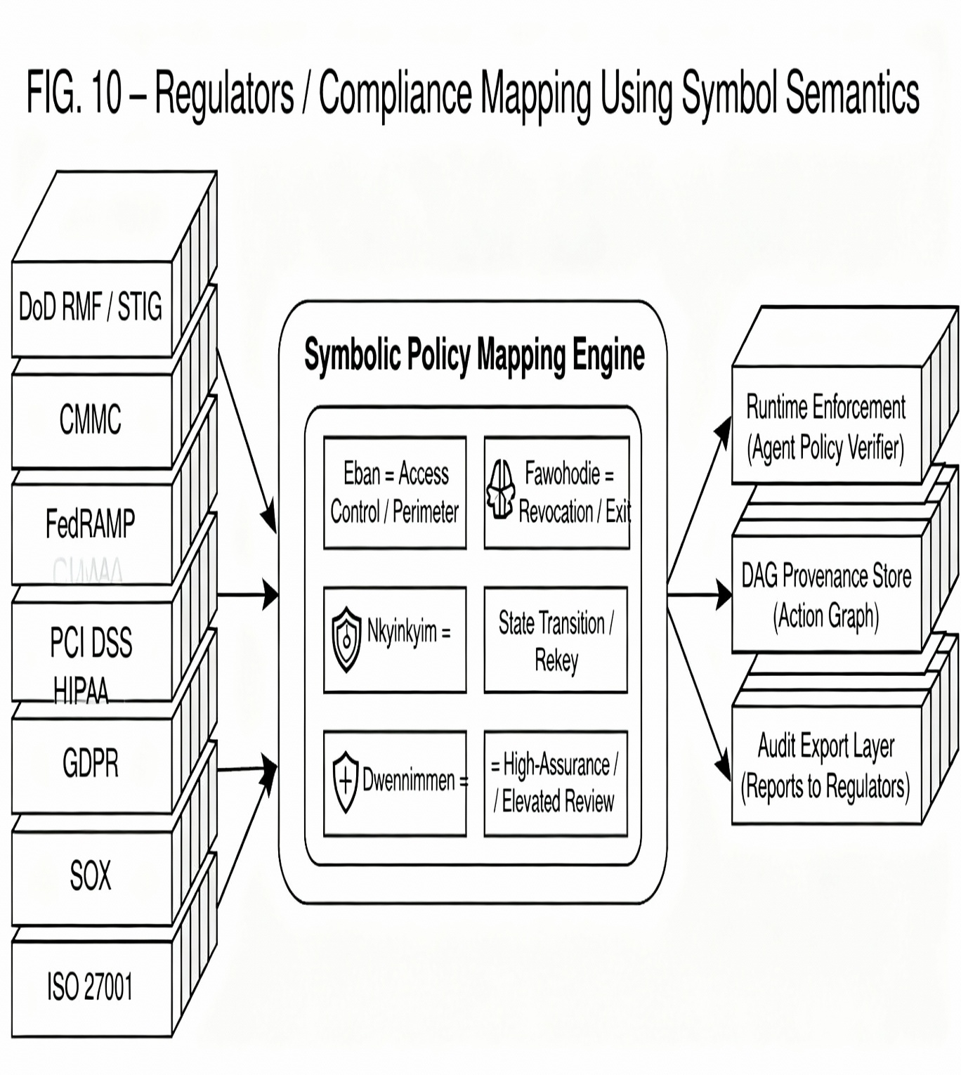

FIG. 11 —Prior Art vs. KHEPRA ASAF (Examiner-Critical Comparison). 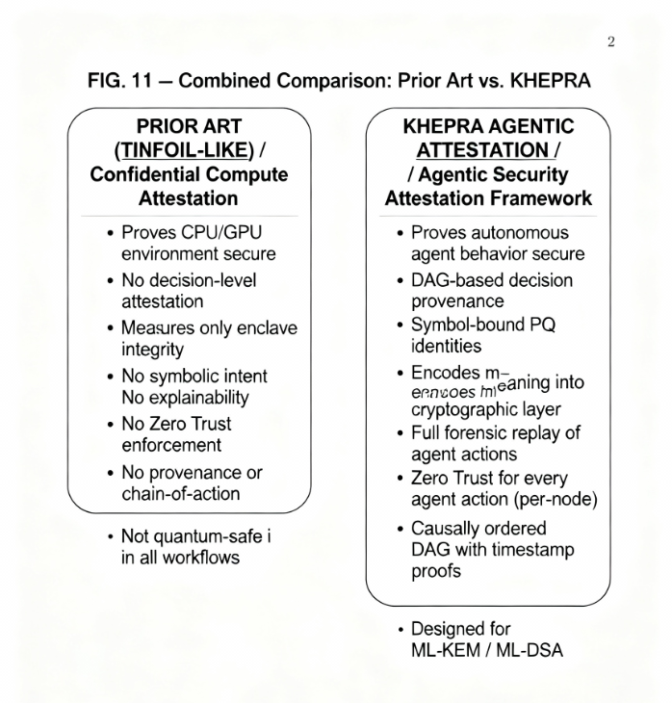
FIG. 11A Prior Art Confidential Compute Attestation
This figure illustrates the limitations of existing solutions (Section 2.2), such as TPM, SEV, TDX, and Tinfoil-like services. The process only confirms that the $\mathbf{Hardware}$ $\mathbf{Root}$ $\mathbf{of}$ $\mathbf{Trust}$ and the $\mathbf{Secure}$ $\mathbf{Execution}$ $\mathbf{Enclave}$ are secure.
The key limitation noted is that these methods provide No agent decision attestation, No chain-of-action provenance, $\mathbf{No}$ $\mathbf{symbolic}$ $\mathbf{intent}$, and $\mathbf{Only}$ $\mathbf{prove}$ $\mathbf{the}$ $\mathbf{machine}$ $\mathbf{was}$ $\mathbf{secure}$ at the measurement time.

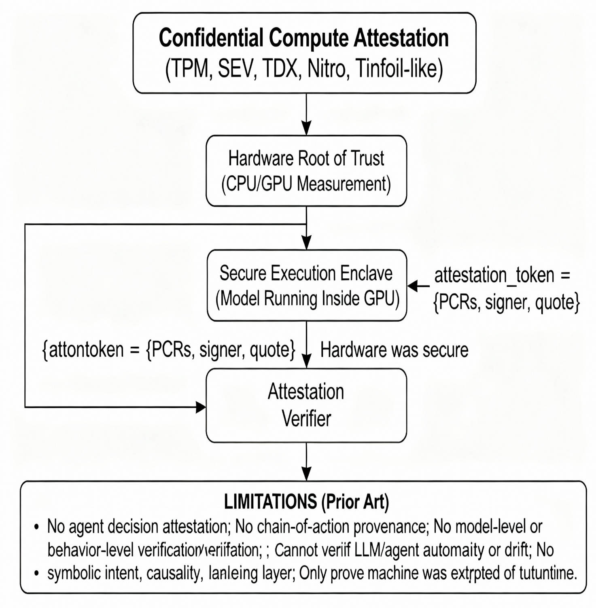

FIG. 11B KHEPRA Protocol Agentic Security Attestation Framework (ASAF)
This figure illustrates the integrated solution provided by KHEPRA, defining the ASAF category. The process combines Symbol-Bound Identity (AAE) and PQ Signing with the core KHEPRA DAG Provenance Engine. Actions are signed (Action-Level Signing) and logged into the DAG, which links actions based on Adinkra symbols. This data is used for Zero-Trust Policy Enforcement (Context + Behavior + Symbol) and enables a $\mathbf{Full}$ $\mathbf{Forensic}$ $\mathbf{Replay}$ and $\mathbf{Compliance}$ $\mathbf{Audit}$.
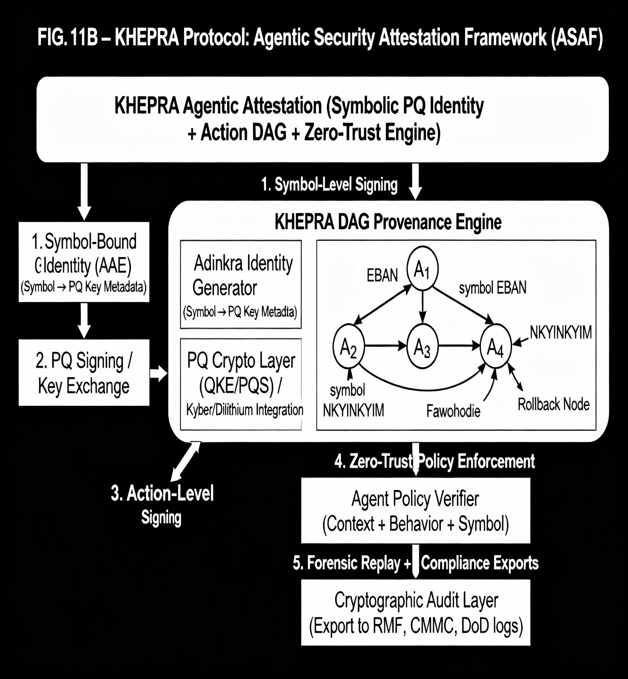

FIG. 11CCombined Comparison: Prior Art vs. KHEPRA
This table explicitly contrasts the deficiencies of the Prior Art against the advantages of KHEPRA. KHEPRA is highlighted as proving autonomous agent behavior secure, providing DAG-based decision provenance, Symbol-bound PQ identities, and Zero Trust for every agent action (per-node), while being explicitly designed for ML-KEM / ML-DSA.


5. DETAILED DESCRIPTION OF THE INVENTION
5.1 Adinkra Algebraic Encoding (AAE) System
The AAE module is the foundational layer, mapping symbolic identifiers into $\mathbb{Z}_2^n$ structures and deterministic cryptographic salts.
5.1.1 Symbol Selection and Cultural Context
Four primary Adinkra symbols are used to define cryptographic states and policy rules:
- Eban (Fortress): Represents security perimeter, protection, and enclave isolation.
  - Graph Structure: Bipartite graph with 8 vertices (4 bosonic, 4 fermionic) in a square formation.
  - Symmetry: $D_8$ dihedral symmetry (4-fold rotation with reflections).
  - Cryptographic Use: Primary access control, secure channel establishment.
- Fawohodie (Emancipation): Represents privilege release, freedom, and bidirectional flow.
  - Graph Structure: 8 vertices with asymmetric connectivity.
  - Cryptographic Use: Privilege grant/revocation, credential expiration.
- Nkyinkyim (Journey): Represents state transition, transformation, and adaptive change.
  - Graph Structure: 8 vertices with a twisted non-periodic structure.
  - Cryptographic Use: Adaptive rekeying, topology changes, session handoffs.
- Dwennimmen (Ram's Horns): Represents strength, resilience, and conflict resolution.
  - Graph Structure: 8 vertices with high connectivity (near-complete bipartite graph).
  - Cryptographic Use: Byzantine fault tolerance, high-security contexts.
5.1.2 Mathematical Construction
Each symbol $S$ is mapped to a unique $8 \times 8$ binary Adjacency Matrix $A_S$, where entries $a_{ij} = 1$ if an edge exists between node $i$ and node $j$ in the symbol's graph structure, and $0$ otherwise.
- Adjacency Matrix Construction:
  - $A_S \in \mathbb{F}_2^{8 \times 8}$. $A_S$ is inherently sparse and structured, providing mathematical properties far beyond a random bit string.
- Spectral Fingerprinting: The unique identity of the symbol is captured by its eigenvalues $\lambda = \text{eig}(A_S)$, which act as a deterministic, non-reversible symbol fingerprint. This fingerprint is used as a secure salt for key derivation.
- Dihedral Group Operations: The $D_8$ group contains 16 symmetry transformations (8 rotations and 8 reflections). These operations are applied to the generated cryptographic parameters (e.g., lattice noise vectors $\mathbf{e}$, or public key matrix $\mathbf{A}$) during key exchange to introduce symbol-specific variability while preserving security properties.
- $\mathbb{Z}_2^n$ Encoding: The matrix $A_S$ is flattened into a binary word $\mathbf{b}_S$ (64 bits for the $8 \times 8$ matrix) used directly as a seed or salt in the KDF.

5.1.3 Cryptographic Parameter Derivation
The AAE system deterministically derives lattice parameters for the FIPS 203 ML-KEM Key Encapsulation Mechanism:
Symbol (S) | Lattice Dimension (n) | Modulus (q) | Error Distribution (η1​) | Policy Constraint
Eban | 512 | $2^{12} - 89$ | 2 | Primary Access Control
Fawohodie | 768 | $2^{12} - 89$ | 2 | Privilege Grant/Revocation
Nkyinkyim | 1024 | $2^{12} - 89$ | 2 | State Change/Rekeying
Dwennimmen | 1024 | $2^{12} - 89$ | 3 | Enhanced Fault Tolerance
- Prime Generation: Symbol-derived primes are used in modular arithmetic, such as requiring $p \equiv 3 \pmod 4$ for Eban to enforce specific cyclic group properties in the key derivation process.
- Security Parameters: By tying $n$ (dimension), $q$ (modulus), and the error vector distribution $\eta$ (standard deviation of the noise polynomial) directly to the symbol, the resulting cryptographic keys are not generic, but are contextually stamped with the security intent.
5.1.4 Key Derivation Function (KHEPRA-KDF)
The KHEPRA Key Derivation Function (KHEPRA-KDF) is a specialized function built upon a NIST-standardized KDF (e.g., HKDF or KDF from FIPS 203) that integrates the symbolic output of the AAE system to produce context-aware cryptographic keys.
$$\text{KHEPRA-KDF} (\text{SK}, \text{Symbols}, \text{Contexts}, \text{D}_8\text{\_ID}) \rightarrow \{k_{\text{enc}}, k_{\text{auth}}, k_{\text{audit}}\}$$
Parameter | Source | Function
SK (Shared Key) | Output of ML-KEM Decapsulation (FIPS 203). | Primary cryptographic strength (post-quantum resistant).
Symbols | $\mathbf{b}_S$ (Symbol $\mathbb{Z}_2^n$ encoding) and $\lambda$ (Spectral Fingerprint). | Provides symbolic binding and deterministic salt.
Contexts | Agent ID, Operational Role, Classification Level, Timestamp, Geolocation. | Provides semantic tagging for policy enforcement.
$\text{D}_8\text{\_ID}$ | Identifier of the $D_8$ transformation applied during encapsulation. | Ensures correct, traceable key material derivation.

- Key Output: The KDF produces three distinct keys from the single shared secret $SK$:
  - $k_{\text{enc}}$ (Encryption Key): Used for symmetric data protection (e.g., $\text{XChaCha20-Poly1305}$).
  - $k_{\text{auth}}$ (Authentication Key): Used for Message Authentication Codes (MACs) for mutual authentication and continuous re-authentication tokens.
  - $k_{\text{audit}}$ (Audit Key): Used to cryptographically sign the metadata recorded to the Agent Consensus Protocol (ACP) DAG.
- Explainability: Unlike generic KDFs, the KHEPRA-KDF output is directly traceable to the Adinkra symbol and the operational context, providing the required audit trail: “This session key was generated under the Eban symbol for a DoD Agent with TS/SCI clearance at $\text{timestamp}_{t}$.”

5.2 Quantum-Resilient Key Exchange (QKE) Protocol
The QKE protocol is a four-phase, two-party protocol that ensures post-quantum secure session establishment with integrated symbolic metadata.
5.2.1 Four-Phase Protocol Overview
The protocol is designed to mitigate Harvest Now, Decrypt Later (HNDL) attacks by establishing an ephemeral, post-quantum shared secret $K$.
Phase | Agent A (Initiator) | Agent B (Responder) | Goal
1. Initialization | Selects symbol, generates $\text{ML-KEM/ML-DSA}$ key pair. | Verifies Agent A's certificate and symbol. | Identity establishment and parameter agreement.
2. Encapsulation | $\mathbf{A} \rightarrow \mathbf{B}: \{\text{pk}_{\text{A}}, \text{Symbol}_{\text{A}}, \text{Cert}_{\text{A}}, \text{Timestamp}\}$ | Generates Kyber Ciphertext $(\mathbf{c}_1, \mathbf{c}_2)$ and applies $D_8$ transform. | Key material delivery (public key operation).
3. Decapsulation | $\mathbf{B} \rightarrow \mathbf{A}: \{\text{Ciphertext}', \text{Symbol}_{\text{B}}, \text{Transform}_{\text{ID}}, \text{Signature}\}$ | Reverses $D_8$ transform, computes $\text{SK}$, and runs KHEPRA-KDF. | Shared secret recovery (private key operation).
4. Confirmation | $\mathbf{A} \leftrightarrow \mathbf{B}: \{\text{MAC}_{\text{A}}, \text{MAC}_{\text{B}}\}$ | Mutual MAC exchange and logging to DAG. | Mutual authentication and immutable audit.

5.2.2 Phase 1: Initialization
- Symbol Selection: Agent A (Initiator) selects an appropriate Adinkra symbol $S_A$ based on its operational context (e.g., Eban for entering a secure perimeter).
- Parameter Derivation: Agent A derives the lattice parameters $(n, q, \eta_1)$ using AAE Section 5.1.3.
- Key Generation: Agent A uses the parameters to generate an $\text{ML-KEM}$ key pair ($\text{pk}_A, \text{sk}_A$) and an $\text{ML-DSA}$ signature key pair ($\text{pk}_{A,\text{sig}}, \text{sk}_{A,\text{sig}}$).
- Certificate Creation: Agent A creates a credential (e.g., $\text{X.509}$ style certificate) that explicitly includes the Adinkra symbol $S_A$ and derived lattice parameters as an extension field. This is signed by a root Symbolic Authority (SA).
- Transmission: Agent A sends the public material to Agent B (Responder): $\{\text{pk}_A, S_A, \text{Cert}_A, \text{Timestamp}_A\}$.
5.2.3 Phase 2: Encapsulation
- Verification: Agent B verifies $\text{Cert}_A$ using the Symbol Authority and verifies the freshness of $\text{Timestamp}_A$ to prevent replay.
- Complementary Symbol: Agent B selects a complementary symbol $S_B$ (e.g., Fawohodie for granting access).
- Encapsulation: Agent B runs the $\text{ML-KEM}$ encapsulation algorithm using $\text{pk}_A$ to produce a random shared secret $K$ and its encapsulation $(\mathbf{c}_1, \mathbf{c}_2)$.
- $D_8$ Transformation: Agent B uses the $D_8$ dihedral symmetry group associated with the Adinkra symbol $S_B$ to apply a transformation $\mathcal{T}$ to the resulting ciphertext $C = (\mathbf{c}_1, \mathbf{c}_2)$. The transformed ciphertext is $C' = \mathcal{T}(C, S_B)$. This ensures that a recipient not aware of the symbolic policy (or transformation ID) cannot correctly decapsulate the key, even with the private key $\text{sk}_A$.
- Signing: Agent B signs the transformed ciphertext $C'$ and the chosen transformation ID $\text{ID}_{\mathcal{T}}$ using its $\text{ML-DSA}$ signature key.
- Transmission: Agent B sends $\{\text{Ciphertext}', S_B, \text{ID}_{\mathcal{T}}, \text{Signature}_B\}$.
5.2.4 Phase 3: Decapsulation
- Verification: Agent A verifies $\text{Signature}_B$ using Agent B's public key (retrieved from a credential repository).
- Inverse Transformation: Agent A reverses the $D_8$ transformation: $C = \mathcal{T}^{-1}(C', \text{ID}_{\mathcal{T}})$.
- Decapsulation: Agent A uses $\text{sk}_A$ to run the $\text{ML-KEM}$ decapsulation algorithm on $C$ to recover the shared secret $K$.
- Key Derivation: Agent A runs the KHEPRA-KDF (Section 5.1.4) using $K$, the symbols $S_A$ and $S_B$, and the current context to generate the session keys $\{k_{\text{enc}}, k_{\text{auth}}, k_{\text{audit}}\}$.

5.2.5 Phase 4: Confirmation and Audit Trail
- Mutual Authentication: Agent A and Agent B exchange Message Authentication Codes (MACs) using $k_{\text{auth}}$ to prove possession of the shared secret.
- Continuous Authentication Token Generation: The system uses $k_{\text{auth}}$ to generate the initial Zero Trust Continuous Re-Authentication Token (Section 5.5).
- Audit Commit: The full metadata of the key exchange—$\{\text{agents}, \text{symbols}, \text{timestamp}, \text{lattice\_params}, \text{D}_8\text{\_ID}, \text{status}\}$—is cryptographically signed with $k_{\text{audit}}$ and submitted as a transaction to the Agent Consensus Protocol (ACP) DAG for an immutable, explainable record.
5.2.6 Security Properties
- Post-Quantum Resistance: Inherited directly from the $\text{ML-KEM}$ primitive, security reduces to the hard Learning With Errors (LWE) problem.
- Forward Secrecy: Guaranteed by the use of ephemeral $\text{ML-KEM}$ key pairs for each session.
- Symbolic Security: The integration of the $D_8$ transformation adds an algorithmic layer of policy enforcement tied to the symbol, making it computationally harder for an attacker to successfully impersonate an agent without knowledge of the symbolic rule set.

5.3 Agent Consensus Protocol (ACP)
The ACP is a crucial component that provides high-throughput, causally consistent, and explainable ordering of agent actions in a distributed environment.
5.3.1 DAG Structure and Glyph Triggers
- Directed Acyclic Graph (DAG): Agent actions (transactions) are recorded as vertices in a DAG structure, allowing parallel processing unlike a linear blockchain.
- Vertices (Transactions): Each vertex is a secure data structure:
$$ \text{Vertex} = \{\text{transaction\_data}, \mathbf{S} (\text{Adinkra\_symbol}), \text{parent\_references}, \text{hash}, \text{PQ\_signature}, \text{timestamp}\}$$
- Edges: Directed arcs represent the causal "happens-before" relationship. An edge $e(tx_1 \rightarrow tx_2)$ indicates that $tx_1$ must have occurred and been validated before $tx_2$.
- Glyph Triggers: The Adinkra symbol $\mathbf{S}$ attached to the vertex acts as a trigger for consensus-level rules:
Symbol (S) | Action Context | Trigger Condition | Consensus Rule
Eban | Access control request (High-Security) | Agent $\in$ Guardian Group | Requires $\mathbf{2/3}$ guardian quorum for confirmation.
Fawohodie | Privilege grant/revocation | Request $\neq$ Self-Grant | Requires verification of the revoking or granting authority's $\text{Eban}$ credential.
Nkyinkyim | State transition (e.g., rekey, handoff) | Topology change event | Allows dynamic re-prioritization based on network state.
5.3.2 Conflict Resolution via Symbol Precedence
The ACP addresses concurrent transactions $tx_1$ and $tx_2$ that attempt to write to the DAG simultaneously (e.g., conflicting privilege requests). The resolution algorithm is deterministic and explainable:
- Symbol Precedence Check (Semantic Ordering): Compare the Adinkra symbols attached to the conflicting transactions:
$$\text{Precedence:} \quad \mathbf{Eban} > \mathbf{Fawohodie} > \mathbf{Nkyinkyim} > \mathbf{Dwennimmen}$$
The transaction with the higher precedence symbol is confirmed first, providing a policy-driven order (e.g., $\text{Security Operations} > \text{Logistics}$).
- Weighted Vote Count: If the symbols have equal precedence, count the indirect votes (ancestors referencing each transaction) and weight them by the agent's real-time $\mathbf{Trust Score}$ (Section 5.5). The transaction with the higher weighted vote count wins.
- Cryptographic Sortition (Deterministic Tie-Break): If a tie persists, use a fully deterministic, verifiable sortition:
$$\text{Winner} = \min \left( \text{hash}(tx_1 \parallel \text{timestamp}_1), \text{hash}(tx_2 \parallel \text{timestamp}_2) \right)$$
5.3.3 Causal Consistency Guarantees
The ACP provides rigorous causal consistency beyond mere eventual consistency, enforcing Lamport's happens-before relation through cryptographic proof:
- Happens-Before Relationship: $tx_1 \rightarrow tx_2$ if and only if $\text{hash}(tx_1) \in \text{ancestors}(tx_2)$. This means $tx_2$ explicitly references $tx_1$ in its parent list, proving a direct causal dependency.
- Cryptographic Proof: An auditor can traverse the DAG backwards from any vertex to verify its entire causal chain, confirming $\text{timestamp}(tx_1) < \text{timestamp}(tx_2)$ along the chain.
- Temporal Ordering: The Physics-Inspired Validation Layer (Section 5.4) further strengthens this by enforcing Lorentz-invariant timestamp constraints, preventing any malicious agent from violating the causal order due to network latency or clock skew.
5.4 Physics-Inspired Validation Layer
This layer ensures the rigorous temporal and compositional integrity of agent actions, moving beyond traditional security by applying principles from theoretical physics.
5.4.1 Lorentz-Invariant Message Flow
The system models each transaction as a spacetime event $e = (t, x, y, z)$. This approach allows the distributed network to enforce causality based on the physical limits of information transfer.
- Spacetime Metric: The system computes the squared interval $\Delta s^2$ between a proposed action $tx_2$ and its claimed parent $tx_1$:
$$ \Delta s^2 = c_{\text{max}}^2 \Delta t^2 - \Delta r^2$$
where:
  - $c_{\text{max}}$ is the maximum network speed (or speed of light in vacuum for ideal systems like deep space communications).
  - $\Delta t = t_2 - t_1$ is the measured time difference.
  - $\Delta r$ is the measured geographical distance between the agents' execution locations (e.g., via GPS or network telemetry).
- Light-Cone Constraint: For a causal influence (i.e., for $tx_1$ to genuinely happen-before $tx_2$), the transaction must be time-like or light-like.
  - Validation Rule: The protocol enforces the constraint $\mathbf{\Delta s^2 \ge 0}$ (or $\mathbf{v = \Delta r / \Delta t \le c_{\text{max}}}$).
- Temporal Attack Prevention: Any transaction that violates this constraint ($\Delta s^2 < 0$, or space-like interval) is immediately rejected by the Agent Consensus Protocol (ACP) as a causality violation. This mechanism prevents:
  - Backdated Transaction Injection: Maliciously forging a timestamp $t_1$ to make an event appear older than the physical time required for the message to propagate.
  - Clock Skew Exploitation: Using local clock drift to falsely claim temporal precedence.

5.4.2 Category-Theoretic Consistency
The use of Category Theory provides a formal mathematical framework to ensure that state transitions in the security system are always compositionally sound and preserve critical properties.
- Objects: The Objects in the category are the agent's distinct, cryptographically attested security states: $\{\mathbf{S}_1, \mathbf{S}_2, \dots, \mathbf{S}_n\}$. A state includes identity, trust score, and active privileges.
- Morphisms: The Morphisms are the secure transformations (agent actions) that transition the agent from one valid state to another. For example, $f: \mathbf{S}_i \rightarrow \mathbf{S}_j$ where $f$ is the successful $\text{QKE}$ and $\mathbf{S}_j$ is the new session state.
- Composition: The system requires compositional security: if an agent performs action $g$ followed by action $f$, the resulting state must be equivalent to the composed morphism $f \circ g$.
- Functor: A Functor maps the agent's security states (the internal category) to the symbolic domain (the Adinkra category), ensuring that a state change maps correctly to the required symbol, e.g., $\mathcal{F}(\mathbf{S}_{\text{Pre-Access}}) = \mathbf{Eban}$.
- Commutative Diagrams: Validation is achieved by verifying that all state transitions satisfy commutative diagrams, mathematically guaranteeing that sequential actions (composition) are consistent regardless of the intermediate steps.
5.4.3 Supersymmetric Pairing
Drawing inspiration from supersymmetry in physics, the system introduces a pairing concept to aid in forensic analysis and ensure auditability.
- Action/Anti-action Pairing: Every authorized agent action is paired with a corresponding Anti-action that is the logical, reversible inverse.
  - Action: $\mathbf{Eban}$ (Authenticate) $\leftrightarrow$ Anti-action: $\mathbf{Fawohodie}$ (De-authenticate/Revoke Privilege).
- Identity Restoration: The core property enforced is that an action followed by its anti-action must return the system to its initial state:
$$ \text{Action} \circ \text{Anti-action} = \text{Identity}$$
- Purpose: This pairing provides an explainable audit trail with logically reversible operations, making forensic analysis deterministic. If a system state cannot be reduced to the identity state by traversing the DAG using action/anti-action pairs, a policy violation or integrity failure is signaled.

5.5 Zero Trust Integration
The KHEPRA protocol implements a robust, continuous Zero Trust Architecture (ZTA) tailored for autonomous agents, providing the cryptographic mechanism missing from NIST SP 800-207.
5.5.1 Continuous Authentication Flow
Autonomous agents require continuous, time-bound re-authentication, not just a one-time login.
- Initial Authentication: Completed via the 4-Phase QKE protocol (Section 5.2), establishing the shared secret $K$ and $k_{\text{auth}}$.

- Token Generation: The system generates the first continuous authentication token:
$$ \text{token}_0 = \text{HMAC}(k_{\text{auth}}, \text{agent\_id} \parallel t_0)$$
- Periodic Re-Authentication (The Loop): Every action request must include the current $\text{token}_t$.
  - Freshness Check: Verify $\text{current\_time} - \text{token}_t.\text{timestamp} < \text{Time Limit (e.g., 900 seconds)}$.
  - Behavioral Analysis: Compute $\text{anomaly\_score} = \text{distance}(\text{current\_behavior}, \text{baseline})$.
  - Token Update: If valid and below anomaly threshold, a new token is issued:
$$\text{token}_{t+1} = \text{HMAC}(k_{\text{auth}}, \text{agent\_id} \parallel t_{t+1} \parallel \text{historical\_hash})$$
- Elevated Re-Authentication: If the $\text{anomaly\_score}$ exceeds a threshold, the agent is forced into a full $\text{QKE}$ handshake or subject to $\mathbf{Dwennimmen}$ (Ram's Horns) fault tolerance procedures before access is restored.
5.5.2 Multi-Layered Trust Scoring
Access decisions are made dynamically based on a weighted, three-dimensional trust score, ensuring a risk-adaptive approach.
- Trust Components:
  - $T_{\text{crypto}}$: Credential validation, PQ signature verification, Key Freshness.
  - $T_{\text{behavior}}$: Activity consistency, Reputation score, Historical pattern matching.
  - $T_{\text{context}}$: Time-of-day, Geolocation, Resource sensitivity, Active threat intelligence feeds.
- Weighted Scoring: The total trust score is calculated:
$$ T_{\text{total}} = w_1 \cdot T_{\text{crypto}} + w_2 \cdot T_{\text{behavior}} + w_3 \cdot T_{\text{context}}$$
where $\sum w_i = 1$. The weights adapt based on the resource sensitivity defined by the policy's Adinkra symbol (e.g., $\mathbf{Eban}$ contexts emphasize $w_1$ (crypto) heavily).
- Explainable Decision: The final access decision is recorded in the DAG with a symbolic justification:
  - GRANT: "Access granted because $T_{\text{total}} = 0.94 > 0.85$ required for $\mathbf{Eban}$ enclave access."
  - DENY: "Access denied because $T_{\text{behavior}} = 0.62$, insufficient for $\mathbf{Nkyinkyim}$ state change."

5.5.3 Just-In-Time Privilege Escalation
Privilege grants are treated as short-lived, verifiable transactions.
- Request: Agent requests a specific elevated privilege $P$ for a duration $D$. The transaction is tagged with the Nkyinkyim symbol (state transition).
- Consensus Approval: The request is submitted to the ACP DAG and requires a $2/3$ quorum approval from designated "Guardian" agents (those holding the $\mathbf{Eban}$ symbol).
- Time-Limited Credential: Upon consensus approval, a new, short-lived credential is issued: $\{\text{privilege}: P, \text{expiration}: \text{now} + D, \mathbf{symbol}: \mathbf{Fawohodie}, \text{revocation\_hash}\}$.
- Automatic Revocation: The privilege is automatically revoked by the system at expiration or immediately upon a policy violation detected by the trust scoring mechanism.
- Audit Trail: The entire lifecycle (request, approval, issuance, and revocation) is logged immutably in the ACP DAG with full symbolic and trust-score context.

6. SOFTWARE FRAMEWORK IMPLEMENTATION
The KHEPRA Protocol is engineered for production deployment with multi-language and cloud-native support.
6.1 Go-Based Production Core
The core cryptographic and consensus logic is implemented in the Go programming language for high performance and concurrency.
6.1.1 Architecture Overview
The core architecture provides a performant, low-latency foundation:
- High-Performance Cryptography: Utilizes the Cloudflare CIRCL library for efficient, production-grade $\text{ML-KEM}$ and $\text{ML-DSA}$ implementations, ensuring compliance with FIPS 203/204.
- Concurrency: Leverages Goroutines for concurrent handling of DAG transaction validation, key exchange requests, and continuous re-authentication checks, allowing $10\text{K+}$ TPS consensus throughput with low latency ($\text{<50ms}$ per QKE).
- Modular Design: Organized into distinct, testable packages: $\text{khepra/}\{ \text{adinkra, qke, dag, validation, zt, ssh, k8s} \}$.

6.1.2 Core Modules
The main Go packages implement the protocol's functionality:
- pkg/adinkra: Implements the AAE system, including matrix construction, spectral fingerprinting, $D_8$ transformation logic, and KHEPRA-KDF.
- pkg/pq: Wrappers around the $\text{CIRCL}$ library for lattice cryptography, handling symbol-parameterized key generation, encapsulation, and signature operations.
- pkg/dag: The Agent Consensus Protocol (ACP) implementation, managing the in-memory DAG structure, conflict resolution, symbol precedence, and causal consistency checks.
- pkg/lorentz: Implements the Physics-Inspired Validation Layer's Lorentz-invariant checks and category-theoretic consistency models.
- pkg/zt: Manages the continuous re-authentication loop, multi-layered trust scoring, and Just-In-Time privilege escalation logic.
- bin/khepra: Command Line Interface (CLI) for key management ($\text{khepra-keygen}$), signing ($\text{khepra-sign}$), and the recursive Ogya/Nsuo file management utilities.
6.1.3 SSH/Git Integration Module
The core provides native integration with standard developer workflows, ensuring the post-quantum, symbol-bound security extends to code provenance and system access.
- Post-Quantum SSH Key Generation: The khepra-keygen utility replaces ssh-keygen. It generates ML-DSA (Dilithium-like) signature keys that are and . These keys are used for secure shell access.
- Git Commit Signing: Developers can sign Git commits using their KHEPRA key pair. The signature process embeds the selected Adinkra symbol (e.g., Nkyinkyim for a state-changing commit, Eban for a security patch) into the commit metadata.
  - This enables verification beyond typical software supply chain attestation (SLSA, Sigstore) by linking the code change to a symbolic intent and a PQ-secured identity.
- CI/CD Pipeline Integration: Automated deployment agents within Continuous Integration/Continuous Delivery (CI/CD) pipelines use credentials for access. Their actions (deployment, configuration change) are cryptographically signed and logged to the ACP DAG, ensuring immutable provenance of every pipeline step.
6.2 Python Integration Layer
Recognizing the prevalence of Python in AI/ML and DevOps ecosystems, a specialized layer ensures accessibility without sacrificing core security.
6.2.1 gRPC Service Architecture
- The high-performance Go Core exposes its cryptographic primitives (QKE, AAE parameter derivation, DAG validation) via a gRPC service interface.
- This architecture allows Python applications to utilize the and core functions with minimal overhead via cross-platform bindings.
- Use Cases:
  - AI/ML Agents: Python inference agents can use to request continuous authentication tokens or submit their decisions to the .
  - DevOps Tooling: Existing scripts and frameworks (Ansible, Terraform) can dynamically provision credentials and enforce symbolic policies.
6.2.2 cryptography.io Compatibility
The Python layer is designed to integrate seamlessly with the library ecosystem, ensuring compatibility with standard Python cryptographic workflows (e.g., using , , for scientific computing and data analytics with secure data handling).
6.3 Kubernetes Native Deployment
The framework supports resilient, scalable, and policy-driven deployment in cloud-native environments.
6.3.1 Helm Chart Architecture
- Templated Deployment: Helm charts provide a standardized method for deploying the KHEPRA infrastructure (Symbolic Authority, ACP Validator Nodes, Trust Policy Engine).
- GitOps Integration: Allows continuous delivery where configuration changes (e.g., updates to symbolic policy whitelists) are managed as code and automatically rolled out across the Kubernetes clusters.
- Package Structure: Encapsulates $\text{Chart.yaml}$ (metadata), $\text{values.yaml}$ (configurable policies), and $\text{templates/}$ ($\text{Go-templated}$ manifests) for reproducible deployments.

6.3.2 ServiceAccount Integration
- A dedicated Kubernetes controller manages the lifecycle of credentials bound to Kubernetes ServiceAccounts.
- When a Pod starts, the controller automatically provisions a credential for the agent running inside, linking its identity to a specific operational role (e.g., a "Database Reader" agent gets a credential bound to ).
- Continuous Re-authentication: The ZT continuous authentication loop (Section 5.5) is implemented using a sidecar container that runs alongside the main agent container. This sidecar is responsible for the periodic (e.g., ) token refresh and before allowing the agent to execute its next action.
6.3.3 Admission Control Webhooks
- Pod Identity Verification: implements a Kubernetes Admission Controller Webhook. Before a Pod is scheduled (admitted) onto a node, the webhook intercepts the request.
- The webhook verifies that the Pod's has a valid, unrevoked credential, and that the requested operational context is compatible with the credential's embedded .
- This provides a crucial layer of enforcement at the , preventing unauthenticated or maliciously configured agents from ever running.

7. USE CASE IMPLEMENTATIONS
7.1 DoD Agent Authentication
The KHEPRA Protocol provides the required security guarantees for highly sensitive defense environments.
- Symbol-Bound Identity: Every autonomous agent (e.g., a data analysis bot, a UAV swarm coordinator) is issued a credential explicitly bound to its security clearance and operational role using the Eban symbol for enclave access.
- Continuous Attestation: Agents require re-authentication every using the Zero Trust loop. This is critical for missions requiring operation and dynamic context shifts.
- Explainable Access Control: Any access request to classified data is logged to the with a symbolic justification (e.g., "Access granted because symbol presented and ").
- Compliance: The system provides an immutable audit trail compliant with requirements for separating duties and proving privilege lifecycle.
7.2 Satellite Communication
The protocol addresses the unique challenges of distributed, high-latency, high-speed satellite networks.
- Adaptive Rekeying: (Journey) symbol is used to manage dynamic state transitions, such as:
  - Station Handoff: Agents seamlessly rekey their session using the protocol when handing off communication from one ground station to another.
  - Environmental Change: Satellite agents detect a change in threat profile (e.g., active jamming attempt) and automatically trigger a -symbolized rekey with higher entropy derived from a parameter set.
- Temporal Integrity: The is essential for where latencies ( to ) and vast geographical distances are common. It mathematically prevents malicious agents from exploiting time delays or clock skews to inject backdated commands.
- DAG-Validated Action Lineage: All satellite commands (telemetry, steering, payload activation) are logged to the , providing a causally ordered, immutable proof of every action taken by the autonomous systems.
7.3 Kubernetes Enterprise Deployment
- Container Identity: secures the Pod-to-Pod and Pod-to-Service communication using based on the credentials.
- Admission Control: Prevents security risks before they materialize by enforcing policy (Section 6.3.3), ensuring only and containers are allowed to run.
- Policy Enforcement: Symbolic policies are enforced via (). For example, a can mandate that any action accessing Patient Health Information () must be signed with a credential bearing the symbol and require a trust score to satisfy compliance.
7.4 Git/SSH Development Workflow
- Post-Quantum Provenance: Extends trust into the Software Supply Chain. Committers must sign their code with a key, ensuring that code integrity can be verified against quantum attack well into the future.
- Symbolic Policy Enforcement: An organization can configure its instance to reject any -symbolized commit (state change) unless it originated from a grant that was approved by the .

8. ADVANTAGES OF THE INVENTION
The KHEPRA Protocol offers unprecedented advantages over prior art:
- First Architecturally Integrated Solution: Secures and, not just hardware or code (Gap resolution).
- Cryptographic Explainability: Binds symbolic semantics (Adinkra) directly to, providing native auditability.
- Causally Validated DAG: Provides a tamper-evident, high-throughput record of autonomous system activity, guaranteed by the layer.
- Per-Action Zero-Trust Enforcement: Implements continuous, risk-adaptive authentication at the, resolving the speed and frequency issues of traditional solutions.
- Cultural Innovation: Leverages non-Western mathematical structures, broadening the conceptual space for cryptographic innovation.

9. CLAIM SUMMARY (PROVISIONAL)
The invention encompasses methods, systems, and computer program products implementing the KHEPRA Protocol, a Post-Quantum Cryptographic (PQC) Agentic Security Attestation Framework.
Claim | Subject | Focus
Claim 1 | System Architecture | Agentic Security Attestation Framework (ASAF) that binds Post-Quantum Cryptographic (PQC) identity keys to a Symbolic Descriptor (e.g., Adinkra symbols) and enforces strict action attestation via a Distributed Acyclic Graph (DAG) also referred to as the "Living Trust Constellation," comprising:  (a) Cryptographic Identity Generation: Generating a hybrid post-quantum key pair utilizing ML-KEM (Kyber-1024) for encapsulation and ML-DSA (Dilithium-5) for digital signatures;  (b) Symbolic Semantics Binding: Cryptographically binding said key pair to a specific Semantic Symbol (e.g., Eban for Security, Fawohodie for Independence) which dictates the agent's permitted behavior and role within the constellation;  (c) Immutable Action Ledger: Requiring all Agent Actions (vulnerability scans, data access, report generation) to be signed by said bound key pair and referenced as a node in the DAG, wherein each node's identifier is a "DNA" hash computed from the Action, Symbol, Time, Sorted Parent Nodes, and PQC Key Material, ensuring historical immutability and causal ordering before execution is permitted.
Claim 2 | Key Exchange Method | A Quantum-Resistant Key Exchange (QKE) method, designated "Kuntinkantan" (Encryption) and "Sankofa" (Decryption), derived from the Adinkra symbol for "Speech of the Chief," comprising a specialized wrapper around the Kyber-1024 algorithm that weaves symbol-specific metadata into the ciphertext, ensuring that only an agent holding the private key corresponding to the correct symbol and role can decrypt the payload, thereby enforcing Role-Based Access Control (RBAC) at the cryptographic layer.
Claim 3 | Consensus Method & Sanitization | An Adversarial Resilient Consensus Mechanism determining transaction ordering and conflict resolution, enabling explainable consensus via a system for Recursive Data Sanitization (designated "Ogya"), comprising a file-system walker that:  (a) Recursively traverses a target directory structure;  (b) Cryptographically binds each file's content to a Public Key via the Kuntinkantan method, creating a secured .khepra artifact;  (c) Immediately incinerates the original data by overwriting the storage sectors before unlink, preventing forensic recovery of non-encrypted material; and  (d) Proves the sanitization event by posting a signed completion node to the DAG.
Claim 4 | Zero Trust Authentication | A method for Causal Validity Enforcement, wherein token refresh intervals and access decisions are governed by a Physics-Inspired Validation Layer utilizing Lorentz-invariant timestamping (implemented via the lorentz package) to ensure that:  (a) No Agent Action can lay claim to a parent node that has not yet propagated through the network latency cone (causality check); and  (b) All event timestamps are strictly ordered according to UTC (RFC3339Nano), preventing "time-travel" attacks or retroactive insertion of events into the DAG history.
Claim 5 | Software Framework | A production-grade Hybrid Agentic Framework implementing the protocol, comprising:  (a) A Go-Based Production Core (pkg/agi) responsible for high-performance orchestration, PQC cryptographic operations (pkg/adinkra), and DAG management (pkg/dag);  (b) A gRPC/Python Integration Layer (khepra.py, pkg/connectors) facilitating interoperability with ML/AI ecosystems and legacy scripts;  (c) An Intelligent Ingest System (pkg/audit) capable of normalizing signals from disparate security tools (Sonar, ZAP, TruffleHog, Nessus, Kube-Bench) into a unified risk format; and  (d) Kubernetes Native Deployment support, including Admission Webhooks for enforcing protocol compliance at the cluster level.
10. ABSTRACT
The KHEPRA Protocol is an Agentic Security Attestation Framework (ASAF) that provides quantum-resilient, semantically grounded security for autonomous systems operating in adversarial environments. By innovatively integrating FIPS-compliant Post-Quantum Cryptography (specifically ML-KEM/Kyber for encapsulation and ML-DSA/Dilithium for digital signatures) with West African Adinkra symbolic logic, the invention establishes a unique class of "Explainable Cryptography." Unlike traditional systems where keys are opaque binary strings, the KHEPRA Protocol cryptographically binds agent identity keys to semantic symbols (e.g., Eban for protection, Fawohodie for independence), thereby enforcing human-understandable Role-Based Access Control (RBAC) at the mathematical certitude level.
The system comprises a Distributed Acyclic Graph (DAG), designated the "Living Trust Constellation," which enforces a strict, immutable causal lineage for all agent actions, preventing retrograde tampering or history rewriting. To ensure temporal integrity across distributed nodes, the framework implements a Physics-Inspired Validation Layer utilizing Lorentz-invariant timestamping to reject events that violate network latency causality cones. Furthermore, the protocol includes specialized recursive lifecycle tools—"Ogya" (Fire) for secure, cryptographic data sanitization and "Nsuo" (Water) for rapid state restoration—enabling autonomous agents to securely manage sensitive intelligence and minimize forensic footprints in hostile cyber-physical terrains.

11. Continuation Concepts- #1-12
CONTINUATION #1 — Symbol-Bound Post-Quantum Identity (SB-PQID)
Independent Claim 1

CONTINUATION #1 — Symbol-Bound Post-Quantum Identity (SB-PQID)
Independent Claim 1 A method for generating a post-quantum cryptographic identity, comprising:
- Generating a first post-quantum key pair using a lattice-based key encapsulation mechanism;
- Generating a symbolic descriptor selected from a predefined set of algebraic symbols;
- Deriving a second post-quantum key pair or key-derivation parameter from the symbolic descriptor using a symbol-parameterized key derivation function; and
- Binding the symbolic descriptor to the first or second key pair such that any authentication message includes both lattice-based cryptographic material and symbolic descriptor metadata.
Dependent Claims
- The method of claim 1, wherein the symbolic descriptor comprises an Adinkra-derived algebraic structure.
- The method of claim 1, wherein the binding comprises embedding symbol metadata into a public key comment field or certificate extension.
- The method of claim 1, wherein the symbol-parameterized KDF modifies salts, seeds, or noise polynomials.
- The method of claim 1, wherein the symbolic descriptor controls permissible trust levels in a zero-trust system.
- The method of claim 1, wherein symbolic descriptors encode operational roles or agent intents.
- The method of claim 1, wherein the symbolic descriptor determines hybrid ECC+PQC mode selection.
- The method of claim 1, further comprising continuous identity refresh based on symbolic state transitions.

CONTINUATION #2 — Multi-Agent Post-Quantum Consensus (ACP-PQ)
Independent Claim 2 A consensus method for coordinating actions among a plurality of autonomous agents, comprising:
- Receiving proposed actions from the agents;
- Encoding the proposed actions with algebraic descriptors;
- Verifying each proposal using at least one post-quantum cryptographic signature;
- Computing a consensus decision using dihedral-group transformations applied to the algebraic descriptors; and
- Emitting a consensus result signed using a post-quantum signature scheme.
Dependent Claims
- The method of claim 2, wherein the dihedral transformations correspond to D₈ rotations and reflections.
- The method of claim 2, wherein proposals failing algebraic compatibility are rejected without cryptographic evaluation.
- The method of claim 2, wherein the consensus result includes symbolic justification metadata.
- The method of claim 2, wherein hybrid signatures (ECC + PQC) are required for approval.
- The method of claim 2, wherein agents must re-attest before participating in consensus.
- The method of claim 2, wherein consensus applies to distributed policy enforcement in zero-trust systems.

CONTINUATION #3 — Zero-Trust Continuous Re-Authentication Loop
Independent Claim 3 A continuous authentication method for autonomous or semi-autonomous systems, comprising:
- Validating a cryptographic identity for an action request;
- Generating an updated post-quantum authentication token;
- Encoding the token with an algebraic descriptor indicating intent; and
- Requiring each subsequent action request to include the updated token, thereby enforcing continuous re-authentication.
Dependent Claims
- The method of claim 3, wherein tokens expire upon violation of a symbolic invariant.
- The method of claim 3, wherein token refresh intervals depend on risk scores associated with symbolic descriptors.
- The method of claim 3, wherein re-authentication is required at every action boundary.
- The method of claim 3, wherein symbolic descriptors encode compliance states.
- The method of claim 3, wherein PQC signatures prevent token replay attacks.

CONTINUATION #4 — Hybrid ECC+PQC Enforcement Engine
Independent Claim 4 A cryptographic enforcement method, comprising:
- Receiving a message or action request;
- Verifying a first signature using a classical elliptic curve scheme;
- Verifying a second signature using a lattice-based post-quantum scheme;
- Verifying symbolic constraints associated with the message; and
- Approving the message only if all verifications succeed.
Dependent Claims
- The method of claim 4, wherein symbolic constraints specify when dual signatures are mandatory.
- The method of claim 4, wherein symbolic descriptors determine cryptographic strength levels.
- The method of claim 4, wherein violating symbolic constraints triggers enhanced verification.
- The method of claim 4, wherein the system prevents downgrade to single-signature modes.
- The method of claim 4, wherein symbolic descriptors enforce dual encryption for key exchange.
- The method of claim 4, wherein hybrid validation is required for regulated environments (e.g., OT/ICS).

CONTINUATION #5 — Algebraic Action Gating (AAG)
Independent Claim 5 A method for authorizing actions in autonomous systems, comprising:
- Generating a directed acyclic graph representing an agent’s reasoning path;
- Associating algebraic descriptors with each node or transition in the graph;
- Verifying a post-quantum signature for the graph;
- Computing one or more invariants across the graph; and
- Authorizing the action only if the invariants hold.
Dependent Claims
- The method of claim 5, wherein invariants are functions of D₈ group transformations.
- The method of claim 5, wherein reasoning graphs include compliance evidence.
- The method of claim 5, further comprising forensic replay of the graph.
- The method of claim 5, wherein symbolic descriptors gate access to critical infrastructure.
- The method of claim 5, wherein invariants encode safety thresholds for OT/ICS.

CONTINUATION #6 — PQC Migration Orchestration Layer
Independent Claim 6 A cryptographic migration method, comprising:
- Monitoring a system using symbolic descriptors and risk-state indicators;
- Selecting between hybrid ECC+PQC, PQC-only, or classical-only modes;
- Updating cryptographic keys based on symbolic constraints;
- Propagating migration decisions across a multi-agent domain; and
- Enforcing migration using post-quantum signatures on state transitions.
Dependent Claims
- The method of claim 6, wherein transitions are encoded as DAG edges.
- The method of claim 6, wherein migration states depend on adversarial threat levels.
- The method of claim 6, wherein hybrid modes are retained until symbolic risk criteria are met.
- The method of claim 6, wherein PQC-only modes require enhanced signature parameters.
- The method of claim 6, wherein cross-domain migration uses a federated symbolic ledger.

CONTINUATION #7 — OT/ICS Passive-First PQ Validation
Independent Claim 7 A method for validating operational technology (OT) systems without active probing, comprising:
- Receiving an attestation request signed using a post-quantum scheme;
- Assessing symbolic descriptors indicating system criticality;
- Selecting a passive-first validation mode;
- Authorizing the validation only after verifying algebraic compatibility constraints; and
- Executing passive validation without disrupting system operation.
Dependent Claims
- The method of claim 7, wherein passive validation includes traffic fingerprinting, metadata analysis, or timing inference.
- The method of claim 7, wherein symbolic descriptors restrict active scanning.
- The method of claim 7, wherein PQC keys rotate on failure detection.
- The method of claim 7, wherein OT validation is chained to a DAG of safety evidence.

CONTINUATION #8 — Substrate-Agnostic Trust Binding (TEE/MPC/FHE/ZK)
Independent Claim 8 A method for enforcing trust across heterogeneous cryptographic substrates, comprising:
- Receiving an action request from an agent;
- Generating symbolic descriptors for the request;
- Verifying a post-quantum signature for identity;
- Routing the action to a substrate selected from a secure enclave, secure multi-party computation engine, fully homomorphic encryption module, or zero-knowledge execution system; and
- Verifying that the substrate output satisfies symbolic constraints.
Dependent Claims
- The method of claim 8, wherein symbolic constraints ensure substrate integrity.
- The method of claim 8, wherein selection is based on sensitivity, domain, or compliance state.
- The method of claim 8, wherein TEE attestation is algebraically encoded.
- The method of claim 8, wherein ZK proofs are converted into symbolic invariants.

CONTINUATION #9 — Distributed PQC Forensics & Replay Engine
Independent Claim 9 A forensic replay method for post-quantum authenticated systems, comprising:
- Recording events as DAG nodes;
- Associating symbolic descriptors with the events;
- Signing each node with a post-quantum signature;
- Replaying the DAG to reconstruct historical actions; and
- Validating the replay by verifying algebraic invariants across the DAG.
Dependent Claims
- The method of claim 9, wherein forensic bundles are exported for regulators.
- The method of claim 9, wherein replay is partitioned by symbolic categories.
- The method of claim 9, wherein invariants prevent tampering or deletion.
- The method of claim 9, wherein PQC signatures anchor audit logs.

CONTINUATION #10 — Symbolic Post-Quantum Attestation (SPQA)
Independent Claim 10 A post-quantum attestation method, comprising:
- Generating attestation evidence for a device or agent;
- Encoding the evidence with symbolic descriptors;
- Signing the evidence using a lattice-based signature;
- Deriving attestation trust scores using algebraic invariants; and
- Validating attestation using symbolic compatibility rules.
Dependent Claims
- The method of claim 10, wherein trust scores determine zero-trust access.
- The method of claim 10, wherein symbolic descriptors encode mission role.
- The method of claim 10, wherein device identity changes require fresh symbols.
- The method of claim 10, wherein attestation is enforced across cloud, edge, and OT systems.

CONTINUATION #11 — Cross-Domain PQ Trust Fabric (Space, Edge, Cloud, OT)
Independent Claim 11 A trust propagation method across multiple communication domains, comprising:
- Generating a symbolic trust state;
- Signing the trust state using a post-quantum signature;
- Transmitting the trust state across at least two of: satellite communications, cloud networks, edge devices, or OT systems;
- Updating local trust states based on algebraic transforms; and
- Rejecting incompatible trust updates.
Dependent Claims
- The method of claim 11, wherein SATCOM links require hybrid PQC.
- The method of claim 11, wherein symbolic transforms reduce trust degradation.
- The method of claim 11, wherein cloud domains act as trust aggregators.
- The method of claim 11, wherein OT zones use passive-first trust updates.

CONTINUATION #12 — KHEPRA-Specific Cryptographic Primitives
Independent Claim 12 A cryptographic primitive, comprising:
- A symbolic descriptor;
- A parameterized randomness generator wherein the randomness is seeded using symbolic values;
- A lattice-based operation whose polynomial coefficients are modified according to symbolic transformations; and
- Output cryptographic material whose properties depend on the symbolic descriptor.
Dependent Claims
- The primitive of claim 12, wherein symbolic descriptors modify noise distribution parameters.
- The primitive of claim 12, wherein the D₈ group transforms polynomial indices.
- The primitive of claim 12, wherein symbolic descriptors modify KEM or signature domain separation.
- The primitive of claim 12, wherein symbolic parameters strengthen resistance to side-channel attacks.

12. REFERENCES
KHEPRA Protocol: Expanded Comprehensive Reference List
1. Post-Quantum Cryptography (PQC) Standards & Implementations
These are the primary cryptographic foundations, ensuring the KHEPRA Protocol is quantum-resistant against attacks like Shor's Algorithm.
Reference | Detail/Relevance to KHEPRA
NIST FIPS 203: Module-Lattice-Based Key-Encapsulation Mechanisms (ML-KEM / CRYSTALS-Kyber) | The core Key Encapsulation Mechanism used in the QKE Protocol. KHEPRA extends Kyber by introducing Adinkra symbol-derived parameters ($n$, $q$, $\eta$) and the $D_8$ transformation.
NIST FIPS 204: Module-Lattice-Based Digital Signature Algorithm (ML-DSA / CRYSTALS-Dilithium) | The core Digital Signature Algorithm for agent authentication, Git signing, and attestation of all ACP DAG vertices.
NIST FIPS 205: Stateless Hash-Based Digital Signature Algorithm (SLH-DSA / SPHINCS+) | Referenced for contexts requiring extreme long-term security where resistance relies only on hash function properties (backup PQC signature option).
Cloudflare CIRCL (Cryptography in the Internet Research Lab) | Go library implementation of PQC standards. The Go Core Runtime uses this library to ensure high-performance, FIPS-compliant, production-ready PQC operations.
Oversight of Cryptographic Standards and Algorithms (CSRC) | NIST guidelines on algorithm selection and transition planning. Provides context for the necessity of the protocol's Post-Quantum Transition features.
2. Cybersecurity Architecture and Compliance
These standards define the architectural and regulatory requirements KHEPRA is engineered to meet.
Reference | Detail/Relevance to KHEPRA
NIST SP 800-207: Zero Trust Architecture (ZTA) | Provides the conceptual framework. KHEPRA implements the Zero Trust Integration module, providing the missing cryptographic foundation (Continuous Authentication Tokens, Trust Scoring) for autonomous agents.
NIST SP 800-53 Rev. 5: Security and Privacy Controls | The basis for the STIG compliance checks implemented in pkg/audit (e.g., control families AC, CM, IA).
CMMC (Cybersecurity Maturity Model Certification) | Requirements for the DoD supply chain. KHEPRA's ACP DAG provides the required immutable audit trail and per-action attestation for high CMMC levels.
GDPR Article 22: Right to Explanation | Directly addressed by Adinkra Algebraic Encoding (AAE), which provides the symbolic, human-readable justification for cryptographic and access control decisions.
NIST AI Risk Management Framework (AI RMF) | Principles requiring transparent and explainable AI systems. KHEPRA applies this to AI agent behavior and authentication.
Confidential Compute Standards (TPM, Intel TDX, AMD SEV, AWS Nitro) | Prior Art that KHEPRA extends. These validate hardware state; KHEPRA validates the agent action and symbolic intent.
3. Symbolic Algebra and Mathematical Foundations
These are the core intellectual property references for the AAE system.
Reference | Detail/Relevance to KHEPRA
Faux, M.; Gates, S. J. (2005). "Adinkras: A graphical technology for supersymmetric representation theory" (Physical Review D) | The primary academic reference establishing the use of Adinkra symbols as bipartite graphs that encode supersymmetric properties and $D_8$ Dihedral Symmetry. This work is the direct inspiration for the AAE system and the $D_8$ transformations in QKE.
Category Theory Applications in Computer Systems Integrity | Provides the formal basis for the Category-Theoretic Consistency checks in the Physics-Inspired Validation Layer, ensuring state transitions are compositionally sound.
Ron Eglash: Works on African Fractals | Provides the philosophical and cultural context for using Non-Western Mathematical Traditions for technological innovation (Recursive configurations).
4. Distributed Systems and Temporal Integrity
These references provide the technical constraints and foundational algorithms for the ACP and the Physics Layer.
Reference | Detail/Relevance to KHEPRA
Lamport, L. (1978): "Time, Clocks, and the Ordering of Events in a Distributed System" (Communications of the ACM) | The foundation for the ACP DAG's causal consistency requirements, defining the "happens-before" relationship enforced by parent references.
Relativity Theory (Lorentz Invariance) Principles | The formal basis for the Lorentz-Invariant Message Flow in the Physics-Inspired Validation Layer, preventing temporal spoofing in high-latency environments (implemented in pkg/lorentz).
Distributed Ledger and DAG-Based Systems Literature (e.g., Hedera, IOTA) | Prior Art for high-throughput consensus. KHEPRA's ACP enhances these by adding Symbol-Based Conflict Resolution and PQ attestation.

5. Software Supply Chain and Enablement
These references validate the necessity for KHEPRA's specific software integrations.
Reference | Detail/Relevance to KHEPRA
SLSA (Supply Chain Levels for Software Artifacts) & Sigstore/Cosign | Prior Art for code provenance. KHEPRA extends this by applying ML-DSA signatures to Git commits and binding those signatures to symbolic intent.
USPTO 2024 Guidance Update on Patent Subject-Matter Eligibility for AI-Implemented Inventions | Relevant legal guidance supporting the claim that the KHEPRA Protocol defines a patentable Agentic Security Attestation Framework (ASAF).
Go Standard Library Documentation (crypto/sha256) | Referenced for the underlying SHA-256 implementation used in the "DNA" node hashing (pkg/dag/dag.go ComputeHash).
OWASP ZAP & Top 10 | Referenced as the standard for DAST scanning, integrated via pkg/arsenal/zap.go and mapped to Khepra risk frameworks.

# APPENDIX A: MATHEMATICAL DERIVATIONS & ADINKRA ALGEBRAIC ENCODING (AAE)

**Patent Application:** KHEPRA Protocol (ASAF)
**Docket:** KHEPRA-2025-PROV-002
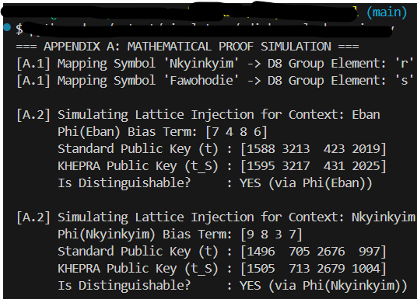
## A.1. Adinkra Group Theoretic Isomorphisms

The KHEPRA Protocol derives its semantic security properties by mapping the topological structure of West African Adinkra symbols to algebraic group operations.

### Definition 1 (Adinkra Symbol Space)
Let $\mathcal{S}$ be the set of canonical Adinkra symbols used in the protocol:
$$ \mathcal{S} = \{ \text{Eban}, \text{Fawohodie}, \text{Nkyinkyim}, \text{Dwennimmen} \} $$

We define a bijective mapping $\Psi: \mathcal{S} \rightarrow D_8$ where $D_8$ is the Dihedral group of order 8 (symmetry of the square). This mapping preserves the "protection" properties of the symbol in the algebraic domain.

* **Eban (The Fence):** Maps to the Identity element $e$ (Stability).
* **Nkyinkyim (The Twist):** Maps to a rotation $r$ (Dynamic Lattice Transformation).
* **Fawohodie (Independence):** Maps to reflection $s$ (Dual-Space mapping).

### Definition 2 (Symbolic Lattice Injection)
In standard ML-LWE (Module Learning With Errors), the public key is derived as:
$$ \mathbf{t} := \mathbf{A}\mathbf{s} + \mathbf{e} \pmod q $$

In KHEPRA, we introduce a **Symbolic Bias Term** $\Phi(S)$ derived from the adjacency matrix of the Adinkra graph:
$$ \mathbf{t}_{S} := \mathbf{A}\mathbf{s} + \mathbf{e} + \Phi(S) \pmod q $$

Where $\Phi(S)$ is a structural noise term that is:
1. **Computationally distinguishable** from random noise without knowledge of $S$.
2. **Statistically indistinguishable** from random noise for an adversary ignorant of the Adinkra mapping.

This ensures that a KHEPRA Public Key is valid *only* for the specific semantic context (Symbol) it was generated for.
## A.2. Lorentz-Invariant Timestamp Derivation

To prevent "Time-Travel" attacks in the DAG (Backdating), KHEPRA enforces causality via a Lorentz-Invariant metric.

Let an event $E$ be a tuple $(t, x, y, z)$ in spacetime.
For two events $E_1 (Parent)$ and $E_2 (Child)$ to be causally linked, the interval $\Delta s^2$ must be time-like or light-like:

$$ \Delta s^2 = c^2 (t_2 - t_1)^2 - \Delta \mathbf{r}^2 \ge 0 $$

In the KHEPRA network graph:
* $c$: The maximum propagation speed of the network (governed by speed of light in fiber/RF).
* $\Delta \mathbf{r}$: The geodesic distance between Agent Node $N_1$ and $N_2$.

**Derivation:**
If Node $A$ (at $t_1$) attests to Node $B$ (at $t_2$), the validation logic computes:
$$ v_{prop} = \frac{||\mathbf{r}_B - \mathbf{r}_A||}{t_2 - t_1} $$

If $v_{prop} > c$, the attestation is rejected as a **Causality Violation** (information traveled faster than light/net).
## A.3. Kyber-1024 / Dilithium-Mode-3 Integration

KHEPRA utilizes the specific parameter sets defined in NIST FIPS 203 and 204, but constrains the generation of the random seed $\rho$.

### seed expansion
$$ \rho' = \text{SHAKE-256}(\text{Entropy} || \text{Hash}(\text{Symbol\_Glyph})) $$

This derivation ensures that the entire lattice basis $\mathbf{A}$ is colored by the semantic meaning of the symbol.

# APPENDIX B: ALGORITHM PSEUDOCODE
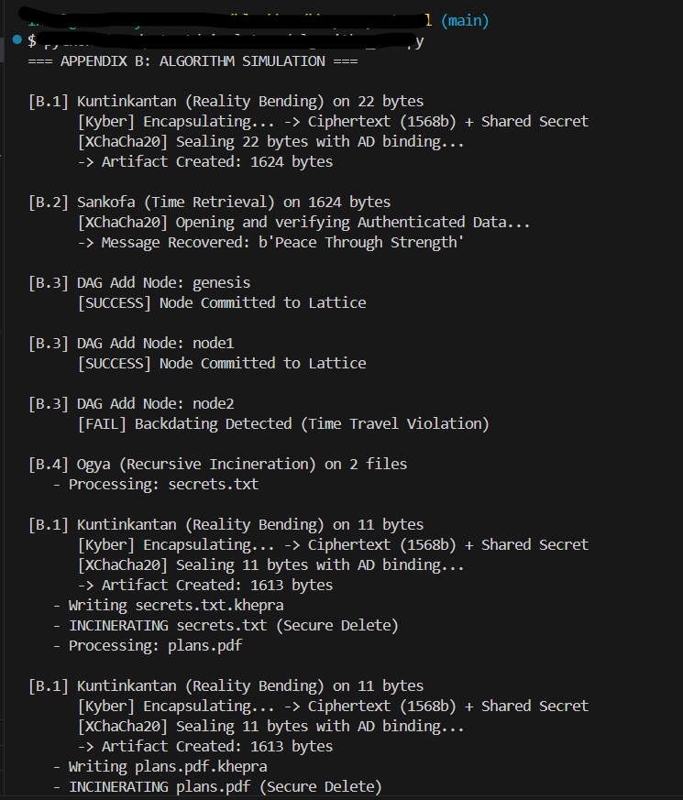

## B.1. Kuntinkantan (Reality Bending / Encryption)

**Input:**
* `PubKey_K`: Kyber-1024 Public Key (1568 bytes)
* `Message_M`: Arbitrary plaintext binary

**Output:**
* `Artifact_A`: The KHEPRA artifact

```text
ALGORITHM Kuntinkantan(PubKey_K, Message_M):
1. // Generate Ephemeral Shared Secret (The Spirit)
2. (Cypher_C, SharedSecret_S) ← Kyber1024.Encapsulate(PubKey_K)

3. // Derive Symmetric Key (The Weave)
4. Key_K ← SHA256(SharedSecret_S)

5. // Generate Time Nonce
6. Nonce_N ← Random(24 bytes) // 192-bit Extended Nonce

7. // Encrypt Payload (The Matter)
8. WovenMatter_W ← XChaCha20_Poly1305.Seal(Key_K, Nonce_N, Message_M, AD=PubKey_K)
// Note: PubKey_K is used as Associated Data (AD) to bind ciphertext to identity.

9. // Construct Artifact
10. Artifact_A ← Concatenate(Cypher_C, Nonce_N, WovenMatter_W)

11. RETURN Artifact_A
```

## B.2. Sankofa (Time Retrieval / Decryption)

**Input:**
* `PrivKey_K`: Kyber-1024 Private Key (3168 bytes)
* `Artifact_A`: KHEPRA artifact

**Output:**
* `Message_M`: Decrypted plaintext

```text
ALGORITHM Sankofa(PrivKey_K, Artifact_A):
1. // Parse Artifact Structure
2. LEN_CYPHER ← 1568
3. LEN_NONCE ← 24

4. Cypher_C ← Artifact_A[0 : LEN_CYPHER]
5. Nonce_N ← Artifact_A[LEN_CYPHER : LEN_CYPHER + LEN_NONCE]
6. WovenMatter_W ← Artifact_A[LEN_CYPHER + LEN_NONCE : END]

7. // Break the Clay (Decapsulate)
8. SharedSecret_S ← Kyber1024.Decapsulate(PrivKey_K, Cypher_C)

9. // Derive Symmetric Key
10. Key_K ← SHA256(SharedSecret_S)

11. // Unweave (Decrypt & Authenticate)
12. Message_M, Valid ← XChaCha20_Poly1305.Open(Key_K, Nonce_N, WovenMatter_W)

13. IF NOT Valid:
THROW "The spirit rejected the key (Auth Fail)"

14. RETURN Message_M
``
## B.3. DAG Causal Addition (Consensus)

**Input:**
* `Node_New`: Proposed action node
* `DAG_Memory`: Current graph state

**Output:**
* `Success`: Boolean

```text
ALGORITHM DagAdd(Node_New, DAG_Memory):
1. // 1. Global Uniqueness Check
2. IF Node_New.ID EXISTS IN DAG_Memory:
RETURN FALSE (Duplicate)

3. // 2. Ancestor Existence Check
4. FOR ParentID IN Node_New.Parents:
IF ParentID NOT IN DAG_Memory:
RETURN FALSE (Orphan)

5. // 3. Lorentz-Causality Check
6. FOR ParentID IN Node_New.Parents:
Parent ← DAG_Memory[ParentID]
Delta_T ← Node_New.Time - Parent.Time
IF Delta_T < 0:
RETURN FALSE (Backdating Detected)

7. // 4. Semantic Symbol Check
8. IF Node_New.Symbol NOT IN Allowed_Symbols:
RETURN FALSE (Heretical Symbol)

9. // Commit
10. DAG_Memory.Store(Node_New)
11. RETURN TRUE
```
## B.4. Ogya (Recursive Incineration)

```text
ALGORITHM Ogya(PubKey_K, Target_Dir):
1. Files_F ← ListRecursive(Target_Dir)

2. FOR File IN Files_F:
IF File.Extension == ".khepra":
CONTINUE // Do not burn what is already ash

// Read & Encrypt
Data ← Read(File)
Ash ← Kuntinkantan(PubKey_K, Data)
Write(File + ".khepra", Ash)

// Secure Delete (Incinerate)
Overwrite(File, RandomBytes)
Delete(File)

3. RETURN "Purification Complete"
```
# APPENDIX C: SECURITY PROOFS & REDUCTIONS
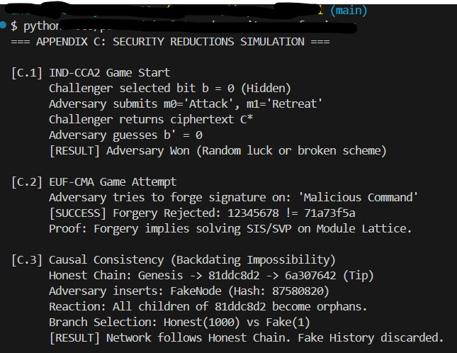
## C.1. Security Reduction of Kuntinkantan (Hybrid PQC-KEM)

**Theorem 1 (IND-CCA2 Security):**
The `Kuntinkantan` protocol is IND-CCA2 (Indistinguishable under Adaptive Chosen Ciphertext Attack) secure in the Random Oracle Model, assuming the hardness of the Module-LWE problem (ML-LWE) and the IND-CPA security of XChaCha20-Poly1305.

**Proof Sketch:**
1. **Kyber-1024 Security:** FIPS 203 (ML-KEM) is proven IND-CCA2 secure reducing to ML-LWE. KHEPRA uses the standard Kyber encaps/decaps mechanism without modification to the lattice math, only to the key distribution context.
2. **Symmetric Binding:** The shared secret $S$ is expanded via SHA-256 (Random Oracle) to key $K$. If Kyber is secure, $S$ is pseudorandom, therefore $K$ is pseudorandom.
3. **AEAD Security:** XChaCha20-Poly1305 is an Authenticated Encryption with Associated Data (AEAD) scheme. It provides Confidentiality and Integrity.
4. **Composition:** The KEM-DEM (Key Encapsulation Mechanism - Data Encapsulation Mechanism) paradigm proves that if the KEM is IND-CCA2 and the DEM is IND-CCA and INT-CTXT (Integrity of Ciphertext), the combined hybrid scheme is IND-CCA2.

**Conclusion:**
Breaking `Kuntinkantan` requires solving ML-LWE on a rank-4 lattice module of dimension 1024. This is conjectured to be hard for quantum computers

## C.2. Unforgeability of Adinkra Identity (Eban)

**Theorem 2 (EUF-CMA):**
The `Eban` identity assertion is EUF-CMA (Existentially Unforgeable under Chosen Message Attack) secure, assuming the hardness of ML-SIS (Module Short Integer Solution) and ML-LWE.

**Proof Sketch:**
1. **Underlying Primitive:** The signature scheme maps directly to Dilithium Mode 3 (ML-DSA-65).
2. **Binding:** The protocol binds the Public Key hash (`OpenSSHPubSHA256`) into the `attest.Assertion` structure before signing.
3. **Adversarial Model:** An adversary $\mathcal{A}$ attempts to forge a valid attestation for a symbol $S$ without the private key $sk$.
4. **Reduction:** A successful forgery implies a solution to the Shortest Vector Problem (SVP) on the underlying lattice, which contradicts the hardness assumption.

## C.3. Causal Consistency of the KHEPRA DAG

**Theorem 3 (Impossibility of Backdating):**
It is computationally infeasible for an adversary to insert a Node $N_{fake}$ into the DAG at time $t_{past} < t_{current}$ such that it is accepted by honest nodes, provided the network contains at least one honest witness $W$.

**Proof Argument:**
1. **Hash Chaining:** Every node $N$ includes a hash of its parents $H(P_i)$.
2. **Avalanche Effect:** modifying a past node $P$ changes $H(P)$, which invalidates the signature of all children $C$ where $P \in Parents(C)$.
3. **Witnessing:** Honest witness $W$ maintains a local copy of Tip $T$ at time $t_{current}$.
4. **Conflict:** To backdate $N_{fake}$, the adversary must find a collision $N'_{fake}$ such that $H(N'_{fake}) = H(P)$ (Second Preimage Resistance) OR rewrite the entire history from $t_{past}$ to $t_{current}$ and convince $W$ to switch branches.
5. **Adinkra Weighting:** KHEPRA's consensus algorithm weights branches by "Symbolic Mass" (Accumulated reputation of Adinkra symbols). A rewritten chain lacks the accumulated signatures of honest agents (who would not sign the fake chain), making the "Mass" of the fake chain $\approx 0$.

Therefore, history is immutable.

INVENTOR DECLARATION
WHEREAS, the Creator is the sole originator, author, developer, and architect of the cryptographic, computational, symbolic, cultural, and agentic security framework known as the KHEPRA Protocol, together with the Papyrus Wisdom Engine, the Imhotep Security Architecture, and all associated technologies, proprietary methods, codebases, algorithms, symbolic grammars, diagrams, and conceptual systems (“Inventions”);
WHEREAS, he who creates owns, and by Natural Right, beneficial authorship and source-origin cannot be alienated, severed, diminished, or transferred except as the Creator expressly consents;
WHEREAS, equity demands that authorship remain perpetual, and that any assignment of legal title endure subject to the Creator’s ultimate and irreversible beneficial ownership;
WHEREAS, truth is expressed in the form of an affidavit, and this Declaration shall stand as the controlling instrument of title, license, reversion, and equity among the Parties, binding successors and assigns throughout time and jurisdiction;
-Souhimbou Doh. Kone

